CHAPTER ONE

INTRODUCTION

BACKGROUND OF THE STUDY
The quality of service delivery all around the world is continuously improved by the usage of computer-based applications. These applications are mostly built based on artificial intelligence which is the area of computer science that focuses on the creation of machines that can perform functions considered as intelligent by humans. These functions performed by the machines are highly sensitive and require knowledge in the domain where these machines are designed to act as if originally, they are in control of situations. The ability to create such machine has intrigued humans since the advent of technology, and today, with the introduction of computers and great research of ages into the field of Artificial Intelligence programming techniques, the production and design of smart machines is becoming a reality as researchers can now build a system which can mimic human thought and understand human behavior via expert system technology.
An expert system is a computer application that performs a task that would otherwise be performed by a human expert; such tasks include but are not limited to making financial forecast, scheduling routes for delivery vehicles, diagnosing human illnesses, and several others. Most expert systems are designed to take human place while others are designed to aid humans. To design an expert system, the domain of the knowledge field is required, so an individual needs to be able to study how the human expert makes decisions and translate the rules used into terms that the computer would understand. Expert system is an example of a symbolic paradigm being one of the two major paradigms for developing intelligent systems in the field of artificial intelligence.

STATEMENT OF THE PROBLEM
The continuous increase in population without a corresponding increase in medical infrastructure, biased, , inconsistency, retirement or death of human experts, has brought about drastic limitations in health care sector this has made it necessary to think of designing an expert system that can assist the health sector in the diagnosis of HIV/AIDS.

SIGNIFICANCE OF THE STUDY
The relevance of this study cannot be overemphasized as the numerous challenges faced in the medical area of HIV/AIDS are so obvious that most health practitioners tend to shy away from providing services, this has put much work load on the few agencies offering such services, which are mostly non-governmental organizations. An expert system for diagnosing HIV/AIDS is therefore a system with enormous level of significance that cannot be undermined; this system will be of great benefit to not just man but also government and health sectors. The obvious challenges faced by the government, health sector and individual are enough to suggest that the relevance of the system are not limited to but include the following;
Professionalism: This system shall contain valid and well researched algorithm that shall aid in decision making, this decision support system shall be written on the basis of the manually collected data and enhanced through well designed syntax to take decisions that are seen to be from facts already programmed, by this the system tends to be very professional and reliable. The system is also not prone to mistakes and can be easily updated.
Reduced time consumption: One of the major advantages of an expert system is speed, the system to be designed will reduce the time consumption of record handling and enhance efficiency as the workload will be reduced to the minimum level.
Proper data collection: The expert system will use a secured database management system to safely store information that can be collected and made reference to when required.
Confidentiality: The system will handle the issue of the fear of result and status exposure, people believe that with the already existing manual system, their results pass through hands that they should not, with the computerized system, anonymity and patient’s confidentiality will be maintained.
Ease in learning: The time used in learning the procedure of proper diagnosis will be reduced as knowledge of experts using the system will be documented for further reference by those who will be coming in newly from time to time. this will improve learning in the domain

OBJECTIVE OF THE STUDY
The general aim of this study is to design a knowledge based expert system with a medical encapsulation for the diagnosis of HIV/AIDS, and the specified objectives are: grant access to registered client, provide links for client to explore information on HIV/AIDS, perform client’s risk factor analysis through logical test, determine results and display client’s computer-based laboratory test. the system will handle facts about the domain of study and tend to use this known facts with the information provided by the users to check how corresponding it is for an effective decision making.

SCOPE OF THE STUDY
The study covers the design of a knowledge based system in the medical domain of HIV/AIDS diagnosis, the knowledge based system handles symptomatic fields of relatedness to the one understudy where patients are checked through stepwise procedure using the following;
- Voluntary pre-test counseling: This link will handle risk assessment where the person under diagnosis will be briefly introduced to factors that transmit HIV virus and other related ailments, they will also be taught on risk reduction methods where general advice will be given on how to live a medically healthy life.
- Voluntary HIV/AIDS testing: This is done using approved HIV testing protocol which uses three different HIV/AIDS test kits for HIV/AIDS confirmatory test before result is given out.
- Voluntary post counseling: This link handles emotional support and referral, in this aspect, individuals whose test results are made available are advised, and this advice is of two distinct levels;
i If diagnosis reads negative, the individual is advised on how to remain negative and healthy, this is done based on what to do and not to do so as to avoid contacting the virus.
ii If diagnosis reads positive, emotional talks are delivered to show the patients that positive test result does not mean the end as people living with the HIV/AIDS virus can still live a normal and healthy life like everyone else, further tests are then carried on for drug placement and dispensing.

1.6 DEFINITIONS OF TERMS
Artificial Intelligence (Artificial Intelligence): The phrase “Artificial Intelligence” can be defined as the simulation of human intelligence on a machine, so as to make the machine efficient to identify and use the right piece of “Knowledge” at a given step of solving a problem. (Konar, 2000)
Expert Systems (ES): This is a type of computer application that makes decision or solves problems in a particular field such as finance and medicine by using knowledge and analytical rules defined by domain experts (Noran, 2000).
Decision Support System (DSS): This refers to an interactive computerized system that gathers and presents data from a wide range of sources, they are systems and sub-systems that assist people in decision making based on data collected from a wide range of sources (Marek J. Druzdzel and Roger R. Flynn, 2002).
Intelligence: This is a term for referring to general mental capability to reason, solve problems, think abstractly, learn and understand to make decisions (Microsoft Encarta, 2009).
Fact: This is a concept in philosophy that treats both the meaning of the word true and the criteria by which we judge the truth or falsity in spoken and written statements (Microsoft Encarta, 2009)
Domain: The term, domain, refers to a particular area of study, it is also used to describe the scope of a subject and an area of activity over which somebody has influence (Noran, 2000).
Knowledge: This is a theoretical or practical understanding of a subject or domain, those who posses knowledge are called experts, a domain expert is one who has deep knowledge of both facts and rules and strong practical experience in a particular domain (Noran, 2000).
Domain Knowledge: This is that knowledge which is specific to a study area and not general or common sense knowledge (Noran, 2000).
Heuristic Knowledge: These are judgmental knowledge that underlines expertise; they are usually implicit and are not necessarily being explicit even to the expert.
Knowledge Base: This is the part of a program in which rules and other methods of representations are used to store domain knowledge (Noran, 2000).
Inference Mechanism: This provides the reasoning ability that enables the expert system to form conclusions (Noran, 2000).

HIV: This is an Acronym for Human Immunodeficiency Virus, infectious agent that causes acquired immunodeficiency syndrome (AIDS), a disease that leaves a person vulnerable to life-threatening infections (Microsoft Encarta, 2009).
Counseling: Advice or guidance, especially as provided by a professional in a given field (Microsoft Encarta, 2009).
Pre test counseling: This provides an opportunity for clients to explore their risk of HIV, to learn about the strategies for avoiding HIV, and help clients decide whether to take the HIV test (www.patient.co.uk/health/hiv-and-aids).
Counselors: They are persons who have received special training in client centered HIV counseling. They do not only provide information, they also help the client make an informed choice about HIV testing, adoption of safe behavioral practices in order to reduce and minimize HIV transmission and facilitate coping with the psychosocial impact of a positive HIV test result (www.patient.co.uk/health/hiv-and-aids).
Voluntary: It is a self decision that is not based on force from any one, the decision to pursue HIV testing must be made by the client after counseling (Microsoft Encarta, 2009).
Window period: The window period is described as the time it takes for a person who has been infected to test positive for HIV antibodies (www.patient.co.uk/health/hiv-and-aids).
Adherence: Taking medications exactly as prescribed. Poor adherence to HIV treatment increases risk for developing drug resistant (www.patient.co.uk/health/hiv-and-aids).
CD4 T-cells: CD4 T-cells also known as helper T-cells acts as a co-coordinator of the immune response, they are unfortunately the main targets of the HIV. HIV destroys infected CD4 T-cells leading to an overall weakening of the immune system (www.who.int/).
Cluster of Differentiation (CD4) Count: This is also known as CD4 cell count or CD4 Lymphocyte count. It is a laboratory test that measures the number of CD4 cells in a sample of blood (www.who.int/)
Testing: This is a laboratory procedure for detecting ailments, in HIV/AIDS diagnosis, it is a way of detecting antibodies in the serum or plasma, and they include tests like the Elisa test and the rapid HIV tests. (Microsoft Encarta, 2009)
Baseline test: Base line testing includes CD4 count, viral load and resistant testing, the results are used to guide HIV treatment choices and monitor effectiveness of Anti-Retroviral Therapy (ART). Baseline is an initial measurement used as the basis for future comparison (www.who.int/).
Confirmatory test: A specific test designed to confirm the result of an earlier test, it is an important test for eliminating false positive result where a negative sample will tend to read positive (www.who.int/).
Risk reduction: The goal of HIV counseling is to eliminate risk, it is discovered that this can be best achieved through small steps for incremental behavioral changes that bring a reduction in risk of infection (www.who.int/).
Referral: The act or process of directing somebody or something to somebody else, especially of sending a patient to consult a medical specialist (Microsoft Encarta, 2009).
Condom: A close-fitting rubber covering worn by a man over the penis during sexual intercourse to prevent pregnancy or the spread of sexually transmitted diseases (Microsoft Encarta, 2009).
Opportunistic infections: They are infections that take advantage of a weakened immune system; they include bacterial infections, fungal infections, pneumonia e.t.c (Cichocki, 2009).
World Health Organization (WHO): Agency of the United Nations that organizes and funds health-care programs in nearly every country in the world. established in 1948 (Microsoft Encarta, 2009).
UNAIDS: UNAIDS, is the Joint United Nations Program on HIV/AIDS, it is an initiative partnership that leads and inspires the world in achieving universal access to HIV prevention, treatment, care and support (www.unaids.org/).
Antiretroviral Therapy (ART): This is treatment of people infected with Human Immunodeficiency Virus (HIV) using anti-HIV drugs. The standard treatment consists of a combination of at least three drugs (often called Highly Active Antiretroviral Therapy (HAART) that suppresses HIV replication. ART has the potential both to reduce mortality and morbidity rates among HIV-infected people, and to improve their quality of life.
HADS: HIV AND AIDS DIAGNOSIS SYSTEM.

CHAPTER TWO

LITERATURE REVIEW
2.0 HISTORY OF ARTIFICIAL INTELLIGENCE
To however get a detailed understanding about expert systems, a brief history of Artificial Intelligence is unavoidably necessary. The quest for Artificial Intelligence is as modern as the frontiers of computer science and as old as antiquity. The concept of thinking machine began as early as 2500BC, when the Egyptians looked to talking statues for mystical advice (Haack, 2004). Artificial Intelligence as both a term and a science was coined 120 years later, after the operational digital computer had made debut. In 1956, Allen Newell, J.C Shaw and Herbert Simon introduced the first Artificial Intelligent program, the Logic Theorist to find the basic equations of logic as defined in principia mathematica by Bertrand Russell and Alfred North Whitehead. For one of the equations, the Logic Theorist surpassed its inventor’s expectations by finding a new and better proof. Suddenly a true thinking machine that knew more than its programmers evolved and lead to the development of another system called the General Problem Solver (G.P.S). They were developed to imitate human problem solving protocols regardless of the information contained in the domain, however, as time progressed they were said to be weak a method as they covered weak information about their domain of study which led to weak performance in problem solving involving complex domains (Nilsson, 2009).

The foundation of Artificial Intelligence covers several disciplines including but not restricted to philosophy, mathematics, psychology, computer engineering and linguistics. The connectionist paradigm evolved from a model proposed on artificial neurons that mimics the structure of human brain, the model was proposed in 1943 by McColloch and pitts. The rise of Artificial Intelligence continued as Feigenbaum and others at Stanford began the heuristic programming project (HPP) to investigate other problem domains that could benefit from the expert system technology. By this the next major effort was in the area of medical diagnosis, MYCIN was developed by Bruce Buchanan and Dr Edward Shortliffe to diagnose bacterial infection in the blood using about 450 rules. MYCIN is the most widely known expert system in the era of the growth of Artificial Intelligence because of the two reasons below as coined from (Feigenbaum and Buchanan, 1993)
- ts design was based on interviews with several doctors that specialized in particular domains, hence, it contains a number of heuristic rules used in identifying certain infections by physicians.
- It lead to the later development of EMYCIN (Empty MYCIN) which was the first expert/knowledge-based system shell, the development time of EMYCIN was considerably reduced as compared to MYCIN, the researchers developed EMYCIN by taking all the rules out of the system and leaving just an empty shell in which other developers in other domains can just plug in their knowledge base.

From the dark ages also known as the birth of Artificial Intelligence to the era of great expectations also known as the rise of Artificial Intelligence, expert systems have been providing pre-selected rules for decision making within specialized domains of knowledge but are limited by the fixed choice and by the date of the expert opinion embodied in the decision rules. Expert systems have been found to have profound impacts which include reducing time of task from days to hours, minutes to seconds. The benefits of expert system since this time include but are however not limited to improved customer satisfaction, improved quality of products and services, accurate and consistent decision making. They operate in hazardous environments where humans could be exposed to various risks; expert systems have featured and make things easier in various fields such as agriculture, education, manufacturing industries, banking, medicine, and so on. In medicine, diagnosis of patients’ complicated conditions, clinical laboratory identification of bacterial infectious diseases and recommendation of treatments, surgery, emergencies, drugs and toxicology and dentistry are some of the domains for expert system development. Expert systems emulate the decision making ability of human experts, they are designed to solve complex problems by reasoning about knowledge like an expert, and not by following the procedure of a developer as in the case in conventional programming (Meech, 2006).

2.1 INTELLIGENT SYSTEM EVOLUTION
As the attributes of personal computing hardware (speed, memory, storage capacity, and resolution) have doubled since the 1980s, our society has reached a point where no serious performance limitations exist for "intelligent methods" and the computational complexities are now embedded within or subsumed beneath the Human-Machine Interface. As a result, these approaches can be applied to study and solve extremely complex and intricate problems beyond the ability of the human mind to handle in a time frame appropriate for process control. Process control has traditionally tried to maintain a system at a set-point for as much time as possible in response to upsets or disturbances in load variables. Nowadays, the set-points themselves have become disturbances with updates occurring at increasing frequencies as communication and measurement cycles have sped up to bandwidths previously unimaginable (Meech, 2006).
The definition of intelligent systems is a difficult problem and is subject to a great deal of debate. From the perspective of computation, the intelligence of a system can be characterized by its flexibility, adaptability, memory, learning, temporal dynamics, reasoning, and the ability to manage uncertain and imprecise information
Expert systems technology was originally invented in the Artificial Intelligence laboratories in an attempt to apply the state-space search, knowledge representation, and inference techniques developed in early research to some "real-world problems." The hope of the inventors was to demonstrate, especially to those always-fickle funding agencies, that Artificial Intelligence was possible and practical and that thinking about thinking machines was scientifically sound. They succeeded beyond their wildest dreams. Expert systems have evolved as a highly marketable offshoot of research in the subfield of computer science called artificial intelligence (Artificial Intelligence). Since its unofficial inception at the Dartmouth Summer Research Project on Artificial Intelligence in 1956 (attended by well known personalities such as Marvin Minsky, Allen Newell, Herbert Simon, Claude Shannon and John McCarthy), Artificial Intelligence has had as one of its primary goals the creation of ‘thinking machines.’ While this ambitious goal has not yet been attained to anyone’s acknowledgment, there have been substantial advances in what we now know about human thinking and learning. Along the way, research in Artificial Intelligence from the late 1950s to the 1970s at Stanford, MIT and Carnegie-Mellon Universities provided some very powerful techniques for codifying human experience and knowledge so that computers can store it and apply it to solve practical problems. The mid-1970s saw the emergence of the first expert systems for applications (Avron and Feigenbaum, 1981).

According to Barr and Feigenbaum (1981), the mid-1970s saw the emergence of the first expert systems for applications such as medical diagnosis (Mycin, by Shortliffe), chemical data analysis (Dendral, by Lindsay and others), and mineral exploration (Prospector, by Duda and others). Furthermore, Turing is seen to have made a significant and characteristic provocative debate in artificial intelligence. Turing (1950) in his Turing test defined intelligent behavior as the ability of human level performance in all cognitive tasks. The issue of acting humans springs up when intelligent systems interact with people. For example, an expert system explaining how it came to a diagnosis or a natural language processing system has a dialogue with a user. He later concluded that, for any complex decision to be made, or problem to be solved, experts in specific areas have particular knowledge, specific alternatives, the chances of success, and also the benefits or costs that may be inquired. Based on these earlier concepts, intelligent systems were developed and have since been very useful to supervisors and managers with situational assessment and long time planning.

2.2 EXPERT SYSTEM
Expert systems are computer programs that can perform some tasks which typically require the capabilities of a skilled human. These tasks are usually of a decision-making nature rather than physical actions. Examples of such tasks are managing water levels in a wetland, forecasting weather conditions, assessing environmental impacts, and selecting mitigation measures for environmental hazards. As computer programs that contain human expertise, they are referred to variously by the labels expert systems, knowledge-based systems, inference systems or rule-based systems (Abraham, 2005 ).

In the late 1960's to early 1970's, expert systems began to emerge as a branch of Artificial Intelligence. The intellectual roots of expert systems can be found in the ambitions of Artificial Intelligence to develop “thinking computers”. Domain specific knowledge was used as a basis for the development of the first intelligent systems in various domains. Feigenbaum (1981) published the best single reference for all the early systems. In the 1980's, expert systems emerged from the laboratories and developed commercial applications due to the powerful new software for expert systems development as well as the new possibilities of hardware. Feigenbaum (1982) defined an expert system as "an intelligent computer program that uses knowledge and inference procedures to solve problems that are difficult enough to require significant human expertise for their solution". Differences from conventional programs include facts such as: An expert system simulates human reasoning about a problem domain as the main focus is the expert's problem solving abilities and how to perform relevant tasks, as the expert does. An expert system performs reasoning over representations of human knowledge in addition to doing numerical calculations or data retrieval using the knowledge base and the inference engine separately. An expert system solves problems using heuristic knowledge rather than precisely formulated relationships in forms that reflect more accurately the nature of most human knowledge dealing with symbolic values and procedures.

Shu-Hsien (2004) said that Expert system (ES) is a branch of applied artificial intelligence community in the mid 1960’s. The basic idea behind expert system is simply that expertise, which is the vast body of task-specific knowledge, is transferred from a human to a computer. This knowledge is then stored in the computer and users call upon the computer for specific advice as needed. The computer can make inferences and arrive at a specific conclusion. Then like a human consultant, it gives advice and explains, if necessary, the logic behind the advice. Turban and Aronson (2001) provided powerful and flexible means for obtaining solutions to a variety of problems that often cannot be dealt with by other more traditional and orthodox methods. Thus, their use is proliferating too many sectors of our social and technological life, however, their applications categories are; rule-based systems, knowledge-based systems, neural networks, fuzzy expert system, object oriented methodology, case-based reasoning (CBR), system architecture development, intelligent agent (Artificial Intelligence) systems, modeling, ontology, and database methodology together with their applications for different research and problem domains. The goal of expert systems research is to program into a computer the knowledge and experience of an expert. Expert systems are used in medicine, business management, mining natural resources and much more. An alternative way to present them is functionally, i.e., according to the types of problems that they address. The non-exclusive categories that seem to capture most applications are classification, prediction, interpretation, planning, monitoring and control, and analysis. The categorical approach is advantageous because the user then acquires an appreciation of the broad applicability of expert system methodology without becoming distracted by details that are specific to particular applications (Davis and Clark, 1989; The surveys in Hushon, 1987, Moninger and Dyer, 1988).

The areas explained below are some of the fields where expert systems are used, according to Alexander and Fairbridge( 1999). These fields of applying expert system technologies are however not limited to just the underlisted fields as the growth in technology advances day-by-day.

Classification problems are the most common type of application. This is due to the impact of our inherent human need to classify objects and events as being members of particular groupings. A salient characteristic of classification problems is that there is a finite (usually small) and enumerable list of possible groups; this make these problems relatively easy to solve. Hence, all problems that fall into a particular solution group are treated similarly with respect to action. Diagnosis is a very common application problem, where systems are diagnosed in terms of the causes of malfunction. These include biological systems (e.g., trees, crops or fish populations), hydrological and chemical systems (e.g., lakes and streams), mechanical systems (e.g., waste treatment) or physical systems (e.g., hailstorm severity). The cause may be a pathogen, a malfunctioning pump, a parasite, a climate change, and so on. Other non-diagnostic classification systems only seek to place an object or event into a particular category without labeling that category as malfunctional; for example, identification of type of atmospheric inversion, classification of soils, selection of options in insecticides, or identification of species.
Another large class of expert systems applications includes those that deal with prediction, these estimate some important future characteristic of an environmental system based on current details about it. Some examples of prediction problems are forecasting for weather and other environmental phenomena, qualitative modeling of biological or physical systems (e.g., vegetation change, crop production and wildlife populations), and damage estimation (e.g., following toxic contamination, for insect epidemics or for flooding). When these expert systems select their predictions from a small set of possible future conditions, they can also be categorized as classification expert systems. It should be apparent that there is some overlap between classification and prediction problems. In fact, all these categories are non-exclusive, and hence overlaps exist between most of them. In fact, many systems can be categorized in multiple ways.

Interpretation problems are similar to prediction problems except that the characteristic to be estimated is a current one, rather than a future one. Because this characteristic condenses and summarizes the information about an environmental system, it usually carries with it some important management implications. Ways in which expert systems have been applied include hazard and risk ratings (e.g., fire danger rating, and contamination or toxicity potential estimation), environmental assessment (e.g., impacts of human intervention, cost estimation, and report evaluation or generation), data interpretation (e.g., model interpretation, site selection or ranking, species selection and equipment selection), and management actions (e.g., fire suppression, and crop production and treatment prescriptions).

Solutions to the above three categories of problems most often consist of a single action or parameter estimate. Planning type problems, on the other hand, are resolved by specifying an ordered set of actions to be performed. Because a large number of possible action sequences are possible, planning problems tend to be much more difficult to solve and are more computationally costly. Examples of reported applications in this area are catastrophe mitigation (e.g., hazardous site cleanup, and fire suppression), forest and agriculture production (planting, treatment and harvest), construction (e.g., roads or airport runways), and scheduling and resource planning (e.g., for regional water quality, landscape and land use). Expert systems provide a viable approach to solving planning problems because these problems usually have a fairly well defined goal that is constrained by certain of their attributes. Moreover, they are non-quantitative in nature and require a systematic search through a large number of possible solutions.

In contrast to the off-line decision making that is inherent in the problems described above; there are situations in which decisions are made as part of real-time operations, Monitoring and control problems are of this type. In many of these instances monitoring and control activities are intertwined in the sense that a process is monitored by an expert system that also takes action when some condition signals its attention. At other times, an expert system only performs monitoring, and a human being performs the control action. Examples of monitoring and control applications are very few in the environmental sciences, and this category is only mentioned here for the sake of completeness.

2.3 EXPERT SYSTEM COMPONENTS
Most expert systems consist of several distinct components. These are knowledge base, working memory, reasoning engine, explanation subsystem and a user interface. The knowledge base contains the scientific knowledge and experience for the particular area of expertise. Imagine that we are designing an expert system to diagnose automobile engine malfunctions. We might want to include knowledge about spark plugs, fuel pump, battery, starter, fuel injectors, etc., and also how these engine components affect engine operation. A competent mechanic can usually pinpoint engine problems fairly quickly with only a small amount of information about the functioning of the various parts. Often a specialist, such as a mechanic, possesses intuition that he or she has acquired through years of experience. This intuition is often ratified in rules-of-thumb (or good guesses) that allow the specialist to solve problems quickly and effectively. For this type of expert knowledge to be used by a computer it must be represented in some way that the computer can easily manipulate. There are numerous techniques for knowledge representation, but traditionally the most common one is the use of condition-action rules, the expert system operates either in consultation mode or knowledge acquisition mode. The various system components enable it to solve problems for which it has knowledge in the knowledge base, to interact with users, and to explain the rationale for the solutions it reaches. This is further explained in figure 2.1 by Luger and Stubblefield (1989), as a comprehensive review of the techniques of the functions of expert system components (Alexander and Fairbridge, 1999).
Condition–action rules are IF-THEN statements where the consequent action(s) are performed if the premise conditions are true. For example, IF battery charged AND battery-cables = clean AND engine-starting = not cranking THEN check starter. This method of knowledge representation is popular because each rule is modular and contains a ‘chunk of domain knowledge, expert system programmers find rules easy to program, and experts are often able to express their heuristic knowledge in the IF-THEN format. Working memory is like the short-term memory of the expert system. It contains assertions about the problem currently under investigation. These assertions may be obtained from the user (via queries), from external programs, from a real time process, or from external data files. Assertions may be facts gathered from the above sources, or they may be hypotheses which have been inferred from other facts that are already known. Because the ultimate goal of knowledge system consultation is to infer problem solutions, some of these intermediate hypotheses will eventually be solutions. All facts and hypotheses in the working memory together describe the current context, or the current state, of a consultation session. Usually a closed world assumption is assumed, i.e., only those assertions that are present in the working memory are true and all other possible assertions about the state of the world are assumed false. While the knowledge base and working memory are passive entities, the reasoning engine navigates through the knowledge base and registers established assertions in the working memory. A reasoning engine operating on a knowledge base and working memory is how an expert system solves problems. Navigation is performed by the particular control strategy that the reasoning engine employs. A control strategy determines the order in which knowledge base elements (such as rules) are examined in order to arrive at the solution to a problem. Assertions are established as true by the particular inference mechanism used. In a rule-based knowledge representation, the inference method is usually used and rules are selected for evaluation either by the content of their premise conditions (data-driven control) or by their consequent actions (goal-driven control). Details of how the reasoning engine operates are determined by the knowledge representation method used, what types of assertions must be made, and the overall problem-solving methods that are applied. The purpose of an explanation subsystem is to enable the expert system to display to users an understandable account of the motivation for all of its actions and conclusions. Explanation is part of the larger issue of human factors engineering, which also includes the user interface – i.e., the how’s and why’s of a computer system’s interaction with users. Explanation systems are not involved with the correct execution of an expert system. Instead, their purpose is to convince the user that the system’s conclusions are reasonable, to explain how it reached those conclusions, and to aid system developers in debugging the knowledge base and the reasoning methods (Alexander and Fairbridge, 1999).
The term user interface refers to the physical and sensory interaction between computer and user. Functionally, this means how the user inputs information to the system and how information is returned to the user. The more natural (i.e., intuitive and understandable) this interface is, the more effective the human computer interaction will be. Traditionally, this interaction has been serial and text based using the conventional, interactive terminal format. Recent advances in computer interfaces enable expert systems to utilize display graphics, hot graphics (graphical objects that perform some action when activated), point-and-click operations, video, sound and animation. For most software users, the interface is the application, and hence expert systems may fall into disuse if they lack good user–interface capabilities, figure 2.1 shows the basic components of an expert system.
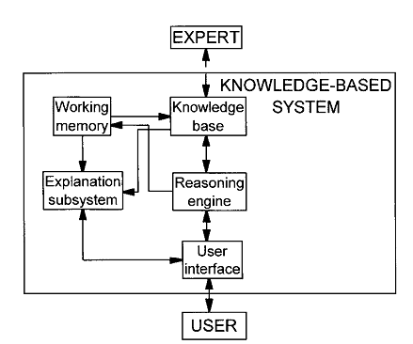

Fig 2.1:Basic components of an expert system Source: Kock, E. D. (2003)
The major components of expert systems that have to be understood are;
Knowledge engineer: This refers to the engineer who encodes the expertise in a declarative format of the knowledge base.
Domain expert: This refers to the individual or set of individuals who are currently experts, solving the problems in a more manual way which the system is designed to solve.
System user: These are individuals who will be consulting with the system to get advice which have already been encoded by the experts.
System engineer: The individual who builds the user interface, designs the declarative formats of the knowledge base and implements the inference engine
Depending on the size of the system to be designed, the knowledge engineer and the system engineer might be the same person. For a custom built system, the design of the format of the knowledge base and the coding of the domain knowledge are closely related. The format has a significant effect on the coding of the knowledge. The development of expert systems may enable a major acceleration in several areas of human endeavors, for instance computer programs have important advantages over books as medium for the recording of knowledge, in that they can be updated rapidly and are necessarily more precise and unambiguous. The availability of the expertise of a leading practitioner in a field in a fully precise and directly testable form may well enable others to find improved ways of teaching the underlying skills. A refined form of the knowledge might again be stored in the form of an expert system, a valuable benefit of designing an expert system, which has been little exploited so far, is the possibility that it may be directly used as an aid for training or educating or other services. Although the pace of development in the expert system field in recent years is extremely impressive, it is hard to escape the feeling that we are still only scratching the surface of a major new technology with potentials which are yet barely appreciated.
Figure 2.2 shows by Unified Modeling Language (UML), how an expert system interacts with its component

User
Domain
Expert

User Interface
Expertise System
Engineer
Inference
Engine

Knowledge
Engineer
Knowledge
Base
Working
Storage
Encoded
Expertise

Fig 2.2: expert system components and human interface (Source: www.myreaders.info/html/artificial_intelligence.html)
For a perfect expert system design, all users are put into consideration and their major functions and activities are linked to them, also, those having relatedness are also linked perfectly to each other as demonstrated in the diagram above.

2.4 EXPERT SYSTEM IN MEDICAL DIAGNOSIS
Expert systems for medical diagnoses are interactive computer programs, designed to assist health professionals with decision making tasks. The clinicians interact with the system using both the clinician knowledge and the system to make a better analysis of the patient’s data than either humans or software could make on their own. Intelligent systems, particularly expert systems for diagnosis and treatment, have been developed for use in a range of medical contexts:
MYCIN: It was the first well known medical expert system developed by Shortliffe at Stanford University (Buchanan and Shortliffe, 1984) used for diagnosis and remedy of bacterial infections. It uses backward chaining inference procedure. It helps doctors, not expert in antimicrobial drugs to prescribe such drugs for blood infections. The limitation of MYCIN is that its knowledge base is incomplete since, it does not cover anything like the full spectrum of infectious diseases. Running it would have required more computing power than most hospitals could afford at that time (1976). Doctors do not relish typing at the terminal and require a much better user interface than that provided.
PERFEX: It is a medical expert system that supports solving problems clinicians currently have in evaluating perfusion studies (Ezquerra et al., 1992). The heart of the PERFEX system is the knowledge base, containing over 250 rules. They were formulated using the expertise of clinicians and researchers at Emory University Hospital. PERFEX limitation resides in its output. It is mostly numerical.
INTERNIST-I: It is a rule-based expert system designed at the University of Pittsburgh in 1974 (Kumar et al., 2009) for the diagnosis of complex problems in general internal medicine.
ONCOCIN: It is a rule-based medical expert system for oncology protocol management (Wiederhold et al., 2001) developed at Stanford University. ONCOCIN was designed to assist physicians with the treatment of cancer patients receiving chemotherapy.
Dxplain: It is a decision support system which uses a set of clinical findings (signs, symptoms, laboratory data) to produce a ranked list of diagnoses which might explain (or be associated with) the clinical manifestations (Elhanan et al., 1996). The Dxplain provides justification for why each of these diseases might be considered, suggests what further clinical information would be useful to collect for each disease and lists what clinical manifestations, if any, would be unusual or typical for each of the specific diseases.
PUFF: It is an expert system for the interpretation of pulmonary function tests for patients with lung disease (Shortliffe et al., 1984). PUFF was probably the first Artificial Intelligence system to have been used in clinical practice.

2.5 MEDICAL DIAGNOSIS SYSTEM
Medical diagnosis, simply termed often as diagnosis refers both to the process of attempting to determine or identify a possible disorder or disease. The history of medical diagnosis began in earnest from ancient Egypt and the day of Hippocrates (The father of medicine) in ancient Greece. In Traditional Chinese Medicine, there are four diagnostic methods namely inspection, auscultation-olfaction (to study sounds arising within organs such as the heart, lung, and stomach prior to treatment), interrogation and palpation (a method of clinical examination using gentle pressure of the fingers to detect growths, changes in the size of underlying organs, and unusual tissue reaction to pressure) (Berger, 1999)
Esagil-kin-apli (1069-1046 BC) introduced the use of empiricism, logic and rationality in the diagnosis of an illness or disease, the book made use of logical rules in combining observed symptoms on the body of a patient with its diagnosis and prognosis. There are a number of methods and techniques that can be used in diagnostic procedure including differential diagnosis or following medical algorithms (Berger, 1999).
Differential Diagnosis: The method of differential diagnosis is based on finding as many candidate diseases or conditions as possible that can possibly cause the signs and symptoms, followed by a process of elimination or at least rendering the entries more or less probable by further medical test.
Pattern recognition: In a pattern recognition method the provider uses experience to recognize a pattern of clinical characteristics. It is mainly based on certain symptoms or signs associated with certain diseases or conditions, not necessarily involving the more cognitive processing involved in a differential diagnosis
DIAGNOSTIC CRITERIA
The term diagnostic criteria designate the specific combinations of signs, symptoms and test results that the clinician uses to attempt to determine the correct diagnosis (www.patient.co.uk/health/diagnostic_criteria).

2.6 HIV/AIDS
HIV stands for Human Immunodeficiency Virus. This is the virus in the group of viruses called retrovirus. HIV destroys cells in the body called CD4 T cells. CD4 T cells are a type of lymphocyte (A white blood cell). These are important cells involved in protecting the body against various bacteria, viruses and other germs. HIV actually multiplies within CD4 cells, it cannot be destroyed by white blood cells as it keeps changing its outer coat so as to protect itself (www.patient.co.uk/health/hiv-and-aids).

AIDS stands for Acquired Immunodeficiency Syndrome. This is the term which covers the range of infections and illness which can result from a weakened immune system caused by HIV. Because ART has altered the way we think about the condition, the term late stage HIV is being used instead of AIDS (www.patient.co.uk/health/hiv-and-aids).

From the above, it can be noted that, HIV and AIDS are not the same thing and persons with HIV infections do not automatically develop AIDS. AIDS is even unlikely to develop in people who have been treated in the early stage of HIV infection. Even in people who do not receive treatment, the time lag is usually several years between first being infected with the virus and then developing infection and other AIDS problems, this is because it usually takes several years for the number of CD4 T cells to reduce to a level where our immune system is weakened (www.patient.co.uk/health/hiv-and-aids).

CONTACTING HIV According to www.patient.co.uk/health/hiv-and-aids, the commonest ways of being infected with HIV include but are however not limited to the following
- Sexual transmission: This is the most common way to pass the virus on. In 2010, it accounted for about 19 in 20 new confirmed cases in the United Kingdom. Semen, vaginal secretion and blood from an infected person contain HIV; the virus can enter the body through the lining of the vagina, vulva, penis, rectum or mouth during sex. Having vaginal or anal sex with an infected person is the most common route. Oral sex carries a much lower risk, but this increases if you have a condition which affects the defense barriers of the mouth like ulcer, bleeding/damaged gums or sore throat. One cannot be infected with HIV by coming into contact with the saliva of an infected persons, HIV is also not passed on by coughing and sneezing.

- Needle sharing: HIV (and other viruses such as hepatitis B and hepatitis C) can be passed on by people who are dependent on inject-able drugs and share needles, syringes and other injecting equipment which are contaminated with infected blood. However, needle-exchange services run by hospitals, clinics and drug dependency units and the more ready availability of medicines taken by mouth has drastically reduced needle sharing as a source of infection.
- Infected blood: In the past, quite a number of cases occurred from infected blood transfusions. This is now rare as since 1985, all blood products are checked for HIV before being used. However, in developing countries, it is still a significant problem.

- From Mother to Child: HIV can be passed to an unborn child from a HIV infected mother. However, with appropriate treatment, the vast majority of babies born to HIV-positive mothers will not have HIV. Achieving this depends on detecting HIV before pregnancy, or, in early pregnancy, when anti retroviral medicines can be taken by the mother. Having a caesarean section to deliver the baby reduces the risk even further. HIV can occasionally be passed to babies through breast milk during breast feeding. If formula milk is available, mothers with HIV are encouraged not to breast feed.

2.7 DIAGNOSING HIV/AIDS
HIV tests are used to detect the presence of the human immunodeficiency virus (HIV), the virus that causes acquired immunodeficiency syndrome (AIDS), in serum, saliva, or urine. Such tests may detect antibodies, antigens, or RNA.
HIV has been found in saliva, tears, nervous system tissue and spinal fluid, blood, semen (including pre-seminal fluid, which is the liquid that comes out before ejaculation), vaginal fluid and breast milk. However, only blood, semen, vaginal secretions and breast milk generally transmits infection to others (www.about.com/Diagnosis of AIDS_HIV.htm). Mandel, Bennet and Dolin (2007) however, stated that AIDS begins with HIV infection. People infected with HIV may have no symptoms for 10 years or longer, but they can still transmit the infection to others during this symptom-free period. If the infection is not detected and treated, the immune system gradually weakens and AIDS develop. The symptoms of AIDS are primarily the result of infection that does not normally develop in individuals with healthy immune system. These are called opportunistic infections. People with AIDS have had their immune system damaged by HIV and are very susceptible to these opportunistic infections. Common symptoms are chills, fever, sweating (particularly at night), swollen lymph glands, weakness, weight loss and others.
The first stage of contracting HIV is known as the primary infection. About 8 in 10 persons develop symptoms at this time. The three most common symptoms (sometimes known as the classic triad) are sore throat, fever and a blotchy red rash. Other symptoms can include feeling sick, diarrhea, swollen glands, headache, tiredness and general aches and pains. The symptoms can last up to three weeks and are often thought of as flu or mild viral illness. After any primary infection settles, the individual can remain without any symptoms for several years hence even without treatment, there are often no symptoms for a long time (often up to 10 years) so as many do not even realize they are infected, however, the virus continues to multiply, the number of CD4 T cells tends to gradually fall and the virus can be passed on to others. During this time, some persons develop persistent swollen lymph glands or night sweats and with time, experience problems such as recurring mouth ulcers, recurring herpes or shingles infections, old Tuberculosis (TB) infections may reactivate in some cases even before AIDS develops, especially in people in the developing world, other symptoms of HIV that may be experienced before AIDS include diarrhea, skin rashes, tiredness and loss of weight (www.patient.co.uk/health/hiv-and-aids.)

The term AIDS is used to describe the advanced stage of HIV infection, people who have an early HIV diagnosis and treatment do not develop this stage. AIDS is a general term which includes various diseases which can result to a weakened immune system. Typically, a person with AIDS has:
- A very low CD4 T cells (around 200 cells per cubic millimeter of blood or below), and/or
- One or more opportunistic infection such as pneumonia, severe thrush in the vagina or mouth, fungal infections, Tuberculosis, etc. these infections can cause a range of symptoms such as sweats, fever, cough, diarrhea, weight loss and generally feeling unwell.
In addition, people with AIDS often have increased risk of developing other conditions as;
- Certain cancers: Kaposi’s sarcoma is a cancer which is actually only seen in people with AIDS. There is also an increased risk of developing cancer of the cervix and lymphoma.
- An AIDS-related brain illness such as encephalopathy (AIDS dementia).
- A severe body wasting syndrome.
The laboratory diagnosis of HIV infection is usually made on the basis of the detection of antibodies to HIV. Serological tests for detecting antibodies to HIV are generally classified as screening assays (sometimes referred to as first-line assays) or supplemental assays (sometimes referred to as confirmatory assays). First-line assays can provide the presumptive identification of antibody-positive specimens, and supplemental assays are used to confirm whether specimens found reactive with a particular screening assay contain antibodies specific to HIV and/or HIV antigen. The most widely used screening assays are enzyme immunoassays (often referred to as EIAs or ELISAs) as they are the most appropriate for screening large numbers of specimens on a daily basis, e.g. blood donations. The earliest assays used purified HIV lysates (1st generation), and often lacked sensitivity and specificity. Improved assays based on recombinant proteins and/or synthetic peptides, which also enabled the production of combined HIV-1/HIV-2 assays, became rapidly available (2nd generation). The so-called 3rd generation or sandwich EIAs, which use labeled antigen as conjugate, are extremely sensitive and have reduced the window period considerably. Enhanced EIAs have been developed that detect both HIV antibody and antigen (4th generation assays) leading to earlier detection of HIV infection and further reducing the window period (Duong et al, 2007).

A variety of simple, instrument-free assays are now available, including agglutination, immunofiltration (flow-through tests), immunochromatographic (lateral-flow tests) and dipstick tests. Specimens and reagents are often added to the test device by means of a dropper. A positive result is indicated by the appearance of a colored dot or line, or by an agglutination pattern. Most of these assays can be performed in less than 20 minutes and are therefore called rapid assays. Other simple assays are less rapid and their procedures require 30 minutes to 2 hours. The results are read visually. In general, these assays are most suitable for use in testing and counseling centers and laboratories that have limited facilities and process low numbers of specimens daily. When a single screening assay is used for testing in a population with a very low prevalence of HIV infection, the probability that a person is infected when a positive test result is obtained (i.e., the positive predictive value) is very low, since the majority of people with positive results are not infected. This problem occurs even when an assay with high specificity is used. Accuracy can be improved if a second supplemental assay is used to retest all those specimens found reactive by the first assay. The negative predictive value will generally always approach near to 100%, irrespective of prevalence. A third assay may also be required to elucidate the correct status (www.who.int/diagnostics_laboratory/en/).

ASSAYS FOR LABORATORY DIAGNOSIS OF HIV
An assay is a quantitative or qualitative test of a substance to determine its components; frequently used to test for the presence or concentration of infectious agents or antibodies e.t.c (Advanced English Dictionary)
According to Jeffery et al (2006), the commonly used assays for HIV rapid tests in laboratories today are;
Determine HIV Rapid Test
The test kit which can appear in any of the form shown in figure 2.3 is used to detect HIV antibodies in serum or plasma. It is termed as first line test, it is the first kit used on the patient, if patient is found reactive, the second line is introduced for conclusion, else the test result is given as negative.
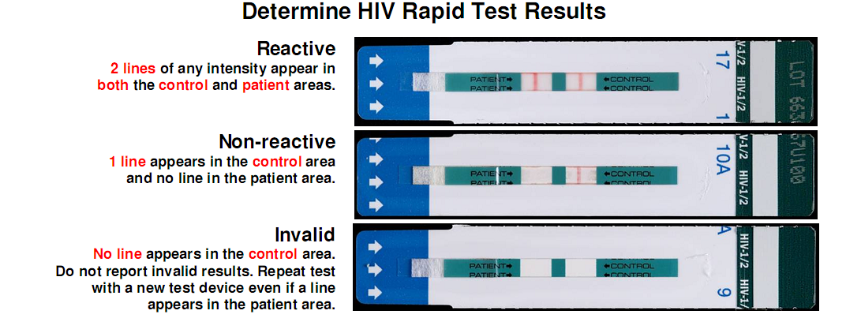

Fig 2.3: HIV positive, negative and invalid test result with Determine Rapid test kit
Source: Jeffery et al (2006)

Uni-Gold Recombigen HIV-1 Test
The Uni-Gold assay which can appear in any of the form shown in figure 2.4 is a lateral flow immunochromatographic procedure for the qualitative determination of HIV-1 antibodies in finger-stick or venipuncture whole blood, serum, and plasma. It is termed the second line test kit as it is used when the first line (Determine) test result is reactive, it is a confirmatory test kit and when its result comes out positive, the client is positive, and else the third line is introduced.

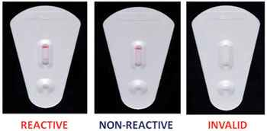

Fig 2.4: HIV positive, negative and invalid test result with HIV uni-gold test kit
Source: Jeffery et al (2006)

HIV 1/2 Stat-Pak
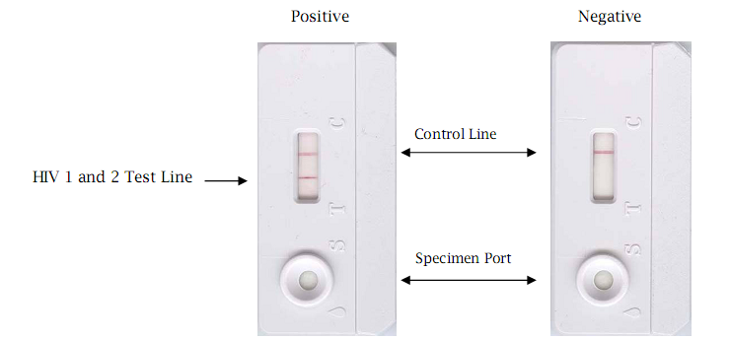
A qualitative immunochromatographic assay which can appear in any of the form shown in figure 2.5 is used for the detection of antibodies to human immunodeficiency virus types 1 and 2 (HIV-1 and HIV-2) in human serum, plasma and whole blood. It is termed as the third line test also known as chain breaker, when used, the result is always final. If the patient test positive to the first two lines and negative to the third, the patient is advised to come back in three months time for testing again
Fig 2.5: HIV positive and HIV negative test result with HIV 1/2 Stat-Pak
Source: Jeffery et al (2006)

2.8 VOLUNTARY COUNSELLING AND TESTING
According to Saeed (2001), ever since the beginning of AIDS epidemic in 1981, the number of people infected and affected by HIV/AIDS is on the rise. During the course of infection, a broad range of physical, social and psychological needs and problems is experienced. Changing nature of the illness imposes a variety of psychological and emotional strains on individuals and those closest to them. Taking into account the dilemmas associated with it, the effects of HIV epidemic are enormous. AIDS, in fact, is seen more as a psychosocial phenomenon than a disease. HIV/AIDS counseling assists people to make informed decisions, cope better with their condition, live more positive lives, and prevent HIV transmission. HIV/AIDS counseling is important because infection with HIV is forever. Role of counseling in HIV/AIDS is perhaps more important than in any other disease.
HIV COUNSELLING
HIV counseling is a confidential dialogue between a client and counselor aimed at enabling the client to cope with stress and take personal decisions related to HIV/AIDS. The counseling process includes evaluating the personal risk of HIV transmission and discussing how to prevent infection. It concentrates specifically on emotional and social issues related to possible and actual infection with HIV and AIDS. HIV counseling has as its objectives both prevention and care. It is important for counselors to have a basic understanding of the HIV antibody tests that may be performed, as well as the necessity of confirmatory HIV antibody testing (Nigerian Federal Ministry of Health, 2011).

Pre-test Counseling
Pre test counseling should focus on two main topics: (a) the person's personal history of risk behaviors or having been exposed to HIV, and (b) assessment of the person's understanding of HIV/AIDS (including modes of transmission), and the person's previous experiences in crisis situations. The aim of pre-test counseling is to provide information about the technical aspects of testing and the possible personal, medical, social, psychological and legal implications of being diagnosed as either HIV positive or negative. Information should be up to date and given in a manner that is easy to understand. Testing of blood donors is different from testing of those suspected of having HIV/AIDS, however, both require enquiring about risk behaviors. Testing should be discussed as a positive act that is linked to changes in risk behavior, coping and increasing the quality of life (Nigerian Federal Ministry of Health, 2013).

Post-test Counseling
The counseling session should begin by trying to put the person at ease. If possible, the room should be quiet, without the fear of being disturbed. Arrange the chairs so that bright light will not shine in anyone's eyes. The counselor should then tell the person the test result in a clear and direct manner. The result (either positive or negative) should then be discussed, including how the person feels about the result. Providing further information might be necessary although the person may be shocked (no matter what the result), and may not fully take in all the information.
However, in some circumstances, this might be the only chance to counsel this person and so
asking them to repeat the information, or have some basic facts written down will be helpful. It is important for the person to have time to reflect on the result and understand the next course of action. Ideally, couple and/or family counseling should be started and further counseling follow-up arranged (Nigerian Federal Ministry of Health, 2013).

HIV - negative Test Result Counseling
If the HIV test is negative, then counseling about risk behaviors and methods of prevention are vitally important. Also, the counselor must explain about the "window period" (between 3-6 months) when a negative result may be a false negative, if there is concern about the HIV status of the person, counsel him to return for a repeat test in 3-6 months. Ensure protection in the meanwhile, explaining that the client could become infected at any time. This is an ideal time to discuss sexual practices and preferences and potential drug abuse (particularly intravenous drug use) and other risk behaviors. The person will probably be more open to learning about safe sex practices and modifying risk behaviors and be willing to consider necessary behavior changes. Free condoms can be given out during this session together with advice on how to use them and where to get more when needed (Nigerian Federal Ministry of Health, 2013).

HIV-positive Test Result Counseling
(The positive test result will only be given after the second HIV test confirms a positive result.) The counselor should tell the person as gently as possible, providing emotional support and discussing how best to cope with the result. This is not the time for speculation, but time to give clear, factual explanations of what the news means. Assess the emotional impact of the news and validate the person's reactions as normal. Fear of dying, job loss, family acceptance, concern about the quality of life, the effects of treatment and response by society might be explored. If there is a concern that the person might not return for follow up counseling, then information about relevant related services might be included, such medical treatment for opportunistic infections, social services for financial and ongoing psychosocial support etc. However, if follow up counseling is an option, then it would be advisable to leave this information to a later date when the person is more able to absorb the details and explore some options. Assess the person's understanding and ability to use preventive methods. Free condoms can be given out during this session together with advice on how to use them and where to get more (Nigerian Federal Ministry of Health, 2013).

HIV TESTING
According to the National guidelines for HIV Counseling and testing by the Nigerian Federal Ministry of Health in November 2011, HIV testing is mainly carried out using anti-body detecting techniques, which include enzyme-linked Immunosorbent Assay (ELISA), simple and rapid tests. Testing is carried out in public and private health facilities including Non-Governmental Organizations (NGOs) and Faith Based Organizations (FBOs) at the following tiers of care:
- Tertiary health facilities like Teaching hospitals, Federal medical centers and Research institutes.
- Secondary health facilities like General hospitals and state specialist hospitals.
- Primary health clinics, community health centers, NGO’s and alone HCT centers, health posts and mobile clinics.
The indications for HIV testing include:
- Need to know one’s health Status
- Screening of donated Blood for organ transplant and transfusion.
- HIV prevalence surveillance in a given population
- Diagnosis of HIV infection in individuals
- Treatment Monitoring
- Research.
LABORATORY HIV TESTING
Persons who become infected with HIV produce antibodies over a period of three(3) months according to the Nigerian Federal Ministry of Health Guidelines for HIV counseling and Testing presentation in November 2011. Different types of tests are available for the detection of these antibodies in adults and children over 18 months of age.
TYPES OF HIV TESTS
  - Rapid Test: Rapid tests are recommended for HCT services because they are fast, simple and accurate. It takes about 15 – 30 Minutes to perform; it can be performed even in clinics without laboratories or specialized laboratory equipment and are accurate when the instructions are strictly followed.
The test is performed using a small sample of blood (taken from the clients finger tip), serum or plasma and the result is ready within 15 Minutes (Nigerian Federal Ministry of Health, 2011).
Enzymes Linked ImmunoSorbent Serologic Assays (ELISA): ELISA test results usually take longer to obtain, and was originally developed for donor blood screening and therefore is more suitable for batch testing in settings where large number of clients are seen daily. Only trained medical laboratory scientist are to perform this test (Nigerian Federal Ministry of Health, 2011).
Virology Test: Virology testing detects the presence of the viral particles and gives the most accurate results; examples include Deoxyribonucleic acid (DNA) and Ribonucleic acid (RNA) by Polymerase Chain Reactions (PCR) tests, P24 antigen tests and viral culture. These tests are not used in HIV counseling and testing services because they are expensive and require high level of skills (Guidelines for HIV Counselling and Testing, November 2011). The test is however recommended for Early Infant Diagnosis (EID) in children less than 18 months of age (Nigerian Federal Ministry of Health, 2011).
RECOMMENDED HIV TEST KITS
An essential requirement of all HIV testing is accuracy of the test result. The rapid test kits used are those approved by health agencies as part of the algorithm by HIV/AIDSDivision of federal ministry of health (Nigerian Federal Ministry of Health)
TESTING ALGORITHMS
Testing algorithms show the strategies to be used for HIV testing, there are three strategies defined by World Health Organization (WHO), based on different principles or methods known as testing algorithm (Nigerian Federal Ministry of Health, 2013).
Serial Testing: With serial testing, an innitial blood sample is taken and tested using the more sensitive kit. If the result is negative, the result is given to the client as HIV negative. If the result is positive, the blood sample is tested using a second HIV rapid test kit, if the second test is also positive, the result is given to the client as HIV positive. However, if the second test is negative, a tie Breaker is used as the third test kit and the result of the tie breaker becomes final (Nigerian Federal Ministry of Health, 2013). The serial testing algorithm flow is shown in the figure 2.6 below.

Test Specimen with Screening Test
Test Result Negative
Test Result Positive
Report as Negative
Test Specimen using a second rapid test with a different antigenic specification
Test Result Negative
Test Result Positive
Report as Positive
Test Specimen using Tie breaker
Test Result Negative
Report as Negative
Test Result Positive
Re-test client in 3 months

Fig 2.6: Serial Algorithm for HIV testing.
Source: Health, F. M. (November 2011). National Guideline for HIV Counselling and Testing.

Parallel Testing: Parallel testing strategy involves use of blood samples (plasma, Serum or whole blood) with two HIV test kits based on different test principles simultaneously (in parallel) and the result issued if both test gives the same result (concordant result), however, if one result is positive and the other is negative (discordant result), the tests are repeated using the same test kits. If the result is still discordant, a recommended tie breaker is used and the result from the tie breaker is given to the client. In cases where the tie breaker is not available, the client is referred to a reference laboratory (Nigerian Federal Ministry of Health, 2011). Parallel algorithm is further explained by the figure 2.7 below.
Test specimen with two rapid test kits of different antigenic specifity at the same time
Both Test Kits give same result?
Yes
Report Test Result as seen
No
Test Specimen on a different Third Test Kit (Tie-Breaker)

Report Test Result as seen

Fig 2.7: Parallel Algorithm for HIV testing. Source: Health, F. M. (November 2011). National Guideline for HIV Counselling and Testing

2.9 DRUG PRESCRIPTION AND DISPENSAL
In the early 1980s, when the HIV/AIDS epidemic began, patients rarely lived longer than a few years. But today, there are many effective medicines to fight the infection, and people with HIV have longer, healthier lives. Although there is still no cure for HIV, treatment is now effective at allowing people with HIV to live their lives as normally as possible. Since the introduction of medicines to treat HIV, the death rate of AIDS has reduced dramatically. With effective treatment, very few people go on to develop AIDS.
HIV is now a treatable medical condition and most people with the virus remain fit and well on treatment. Since the 1990’s, a number of medicines have been developed called antiretroviral medicines. Antiretroviral medicines work against HIV infection by slowing down the replication of the virus in the body, newer medicines are more effective than medicines in the past. There are several classes of these medicines which include Neucleuside Reverse Transcriptase Inhibitors (NRTIs), Neucleutide Reverse Transcriptase Inhibitors (NtRTIs), Protase Inhibitors (PIs) and Non- Neucleuside Reverse Transcriptase Inhibitors (NNRTIs). Newer classes of medicines have recently been introduced which are Integrase Inhibitors, Fusion Inhibitors and CCR5 antagonists. The medicine in each class works in different ways but all work to stop the HIV from replicating itself. This method of treatment is called Anti-Retroviral Therapy (ART), it is still occasionally referred to as Highly Active Antiretroviral Therapy (www.MedlinePlus.htm).

As a general rule, drug dispenser is normally started when
- CD4 T cells has fallen below a certain level (around 350 cells per cubic millimeter of blood or less) even without symptoms, the exact level when drug is dispensed depends on various factors which doctors do discuss with the infected persons during post counseling. These include any symptom present and the rate of decline of the CD4 T cells.
- Opportunistic infections or other AIDS-related problems develop. Opportunistic infections are usually treated with anti-biotics, anti-fungals or anti-TB medicines obviously depending on which infection develops, even if infections have not developed, once the CD4 T-cells fall to a low level, regular doses of one or more antibiotics is being advised or other medicines to prevent certain infections from developing (www.MedlinePlus.html)

CHAPTER THREE

DESIGN METHODOLOGY

3.0 INTRODUCTION
Research Methodology refers to the means necessary to systematically proffer step-by-step description of how solution to actualize stated Objectives of the research work will be carried out. It outlines the various steps that are adopted.
3.1 SYSTEM DESIGN
- Carry out an evaluation of pattern classification algorithms on appropriate datasets using Expert System builder version 3.0. The process of evaluation will involve the following steps;
- Acquisition of relevant HIV/AIDS patient’s symptoms datasets from The General Hospital Aguda Surulere Lagos State.
- Preparation of the acquired data set to a format supported by the expert system software.
- Verify the best method to ensure the accuracy of each of the algorithms used in the experiments.
- The Hiv/Aids Diagnosis system’s Decision Support System (DSS) has a user interface that will be used to feed patient data into the system, the system also has a knowledge base the houses the following modules;
- The diagnostic Module
- The Medical expert knowledge Logic.
The web-based User interface will be developed using;
- Windows 8 operating system, Apache web server, MYSQL database
- PHPMYADMIN
- Cascading style sheet (CSS)
- Hyper text markup Language (HTML)
- Javascript frameworks
3.1.1 DESIGN TOOLS
WAMP PACKAGE
WAMP is the abbreviation of the package; Windows, Apache, MYSQL and PHP.
Apache HTTP server is web server software. PHP stands for hyper text pre-processor,
it is a kind of HTML embedded language which executed on the server. MYSQL
server is small relation database Management system.

Combination of these packages formed a powerful web application platform.
PHP (PHP HYPERTEXT PRE-PROCESSOR): This served as the server side scripting
language and was used to connect to the database along side with HTML code.
HTML (HYPERTEXT MARK-UP LANGUAUGE): This is a mark-up language
that was used to create or design a website of the system.
JAVASCRIPT: This served as the client side scripting Language.
APACHE: This was the server used to execute the web code created with PHP and
HTML.
PHPMYADMIN: This was used to create my database and tables needed in the web
application
LOCAL HOST: This is the host/address of the Local machine used or in use, The IP
address is 127.0.0.1.
MYSQL: This was the type of database used in the course of design.
3.2 SOFTWARE DEVELOPMENT LIFE CYCLE

The software development life cycle (SDLC), also referred to as the application
development life-cycle, is a term used in systems engineering, information system
and software engineering to describe a process for planning, creating, testing and
deploying an information system. It is composed of a number of clearly defined and
distinct work phases which are used by system engineers and system developer to
plan for, design, build, test, and deliver information system. SDLC provides a series
of step to be followed to design and develop a software product efficiently. There are
different types of software development life cycle which are:
- Waterfall model
- Iterative model
- Spiral model
- Agile model
- Prototype model
- RAD model (Rapid application development)
- V- model
- Fish model
In developing the decision support system, the software design methodology used was the waterfall model development process.
3.2.1 WATER FALL MODEL
The waterfall model is a sequential design process, used in software development processes, in which progress is seen as flowing steadily downwards through the phases of conception, initiation, analysis, design, construction, testing, production/implementation and maintenance. In Royce's original waterfall model (2007 Software Engineering Project Management 2nd edition With R. Thayer & Ed Yourdon), the following phases are followed in order: System and software requirements: captured in a product requirements document Analysis: resulting in models, schema, and business rules Design: resulting in the software architecture Coding: the development, proving, and integration of software Testing: the systematic discovery and debugging of defects Operations: the installation, migration, support, and maintenance of complete systems.
Thus the waterfall model maintains that one should move to a phase only when it’s proceeding phase is reviewed and verified.
Various modified waterfall model including Royce's final model, which include slight or major variations on this process. These variations included returning to the previous cycle after flaws were found downstream or returning all the way to the design phase if downstream phases deemed insufficient.

REQUIREMENT
Product requirement document
DESIGN
Software architecture
IMPLEMENTATION
Software

VERIFICATION

MAINTENCE

Fig 3.1: Hierarchy of Expert System development process
(Source: https://en.wikipedia.org/wiki/Winston_W._Royce)
The research methodology and System Design actually follow the hierarchy represented in the figure above. The background, concepts and problem selection are discussed under the same heading as the system study and investigation, where a procedure is undertaken in learning about HIV/AIDS and its various symptoms and available treatment before looking for a way of designing
a system that will be able to use these selected problems to diagnose the ailment. By this, it was learnt that, to be diagnosed, the patient has to go through a process known as Voluntary Testing and Counseling (VCT). The process therefore consists of the basic steps used in the design of the proposed system as it basically involves pre–test counseling, actual testing and post test counseling, by this, the HIV/AIDS Diagnostic System (HADS) is divided into modules to handle the above tasks.

3.3 HIV/AIDS DIAGNOSIS EXPERT SYSTEM MODULES
3.3.1 USER INTERFACE
The user interface serves as the medium through which patient data can be fed into the system for processing. It is also through the user interface that the diagnostic results, reminders, alerts and recommendations are displayed to the user.
The User interface was designed by using:
- Windows 8 operating system, Apache web server, MYSQL database and PHPmyAdmin
- Google Chrome web browser
- Cascading style sheet (CSS)
- Adobe Dreamweaver CS6
- JavaScript frameworks
3.3.2 MEDICAL KNOWLEDGE BASE
The medical knowledge base consists of the following:
- The diagnostic module that contains symptoms, diagnostic results and prescribed recommendation. This module stores relevant information required for diagnosis of HIV/AIDS status and as well as stores the results obtained after diagnosis.
- The medical expert knowledge module that house the knowledge of the medical expert as regards HIV/AIDS. The knowledge acquired from the medical expert is coded into the Expert system by the knowledge engineer. The knowledge from the expert is coded following standard Clinical practice Guidelines (CPGs) for HIV/AIDS.
- The electronic medical record (EMR) that contains the details of all persons that the system has been used to diagnose as regards their HIV/AIDS status. The EMR contains information about a patient’s healthcare that are essential for his or her present and future care (WHO, 2001) and are covered by section 3 of the Health Records Act, 2001 (AustLII, 2012)

3.3.3 INFERENCE ENGINE
The Inference engine serves as the processing component within the system that co-ordinates the activities within the system in such a way as to be able to execute according to the knowledge base with reference to patient’s input data. It therefore generates the appropriate results.
3.4 DATABASE DESIGN
This is the design of the SQL database which consist of the specification of the various relations, fields that the table contains and their corresponding data type as well as the field length specification. In the MYSQL environment, the term database referred to a collection of tables (relations) and other database objects such as indexes.
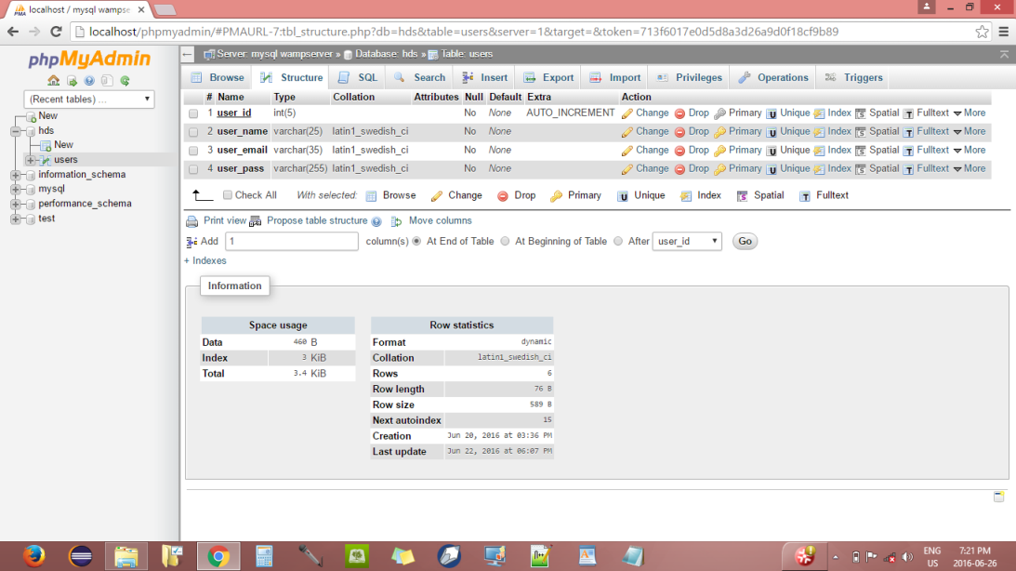
Fig 3.2: System database, Source:127.0.0.1/phpmyadmin
3.4.1 TABLES
One of the most critical components of the database is its table that’s because SQL server uses table to store data. You create a table to contain a set of related information. When you create a table, you define its column; column refers to the individual pieces of information (fields) you want to track for a specific table. You can control how information is stored in a particular column by configuring the properties
PROPERTIES OF A TABLE

DATA TYPE
DEFAULT
CONSTRAINTS
RULE

Fig 3.3: database source table Source: http://downloads.mysql.com/mysql-tutorials

  - DEVELOPMENT OF A PROTOTYPE SYSTEM USING EXPERT SYSTEM
BUILDER VERSION 3.0
Introduction
In the following sections, a brief introduction is given about the designing of the prototype and the expert system shells. The steps involved in the development of the prototype are discussed. Finally the results and observations are tabulated from (Shodhganga ,2013)

Designing a Expert system prototype
Expert systems require special approaches to systems analysis, especially to the collection of the data (or rather knowledge) on which the system is based. The process of gathering the knowledge to stock the expert system's knowledge-base & knowledge acquisition has proved to be the most difficult component of the knowledge engineering process. It's known as the 'Knowledge Acquisition Bottleneck', and expert system projects are more likely to fail at this stage than any other. Knowledge acquisition almost always involves extracting knowledge from someone expert in the specific field. This process of knowledge elicitation involves a variety of interview and non-interview techniques.
The development of Expert systems requires special approach to software management. The methodologies used to build expert systems have been shaped by the problems with knowledge acquisition, described earlier. For a long time, the favourite development methodology was rapid prototyping. (Cyclical development means more or less the same thing). In the mid-1980s, this approach came under criticism, because it appeared to have all the shortcomings of the unstructured approaches which had been used, with very poor results, in the early days of mainstream software. But the structured systems analysis & design methodologies did not seem to be appropriate, because of the differences between knowledge and data. As a result, special-purpose development methodologies for knowledge engineering were developed. The most well known is KADS, (KADS is a development methodology for knowledge-based systems) which was developed at the University of Amsterdam, as part of the ESPRIT programme, in co-operation with several European partners. The phase of prototyping can have the following steps.
i. Build a small prototype
ii. Test, improve and expand it
iii. Demonstrate and analyse feasibility

iv. Complete the design

Prototyping systems development focuses on the iterative creation of a new expert system. Rather than going through the whole SDLC process for everything that could be potentially envisioned with the system, a portion of the system is chosen to use to create a prototype. The prototype does not go through extensive requirements analysis and instead focuses on getting something created quickly for immediate use by end-users in order to gather feedback to either modify the prototype or begin the process again with another component. While the prototyping development method gets users involved in the system's development and typically brings about real results quickly, it can be difficult to manage prototyping-based projects due to its differences with SDLC. The primary level analysis and design is illustrated in figure 3.4
POSITIVE RESULT
NEGATIVE RESULT
Figure 3.4: Primary level of analysis and design, Source: Shodhganga.iniflibnet.ac.in
The process of building an expert system is commonly known as knowledge- engineering. This implies knowledge acquisition from a human or other source and coding it into the knowledge base of the expert system. The main phases in the knowledge engineering process are the dialog process as represented in Fig. 3.5. This is similar to the task of a system designer discussing the requirements of the program with the client, in conventional programming. After acquiring knowledge from the human expert, the knowledge engineer has to explicitly code it into the expert system knowledge-base. After the coding stage, the human expert evaluates the expert system and gives feedback/critique to the knowledge engineer. The knowledge engineer alters the knowledge base in order to reflect the human expert's comments
Fig 3.5 ES-builder Source: Shodhganga.iniflibnet.ac.in
This process will iterate until the human expert finds the expert system satisfactory for the envisaged purpose. Some rule-based systems may display the capability to learn rules by example (rule induction), creating rules from tables of data. Learning is a complex process, hindered by ambiguities, duplications and inconsistencies in the human expert knowledge.
Expert System Shell Used
Expert system shells provide methods of building expert systems without extensive knowledge of programming through mechanisms that
(i) Input the decisions, questions and rules that are followed (ii) Construct a knowledge database that can be manipulated by subsequent parts of the system
(iii) verifies possible violations of surface validity and (iv) operates the "inference engine" that operates on the rules, poses the questions to the users, and determines whether a particular decision is valid. Most expert systems also allow the user to halt the processing at any time to query the system why a question was asked, or how a decision was reached. Most expert system shells can now run easily on most current micro-computers and are able to handle the manipulation of a relatively large number of rules and associated questions. Expert system shells are expert system development tools consisting essentially of the expert system without the knowledge base, embodying the inference engine, working memory, and the user interface . An example of the inference engine part of an expert system that deduces new conclusions from known facts is illustrated below:
IF test results =known
AND Opportunity infection rate=known
AND Opportunity infection = dominant
THEN Client= Suspected HIV/AIDS Positive
Expert systems give advice or solve problems by drawing upon this knowledge stored in the IF/THEN rules. A survey of different expert system shells was conducted. After careful study of the shell for the development of prototype ES-Builder V3.0 is selected

ES-Builder Ver. 3.0 Expert System Shell
ES-Builder Ver. 3 is simple software to build a expert system prototype. It does away with the separate programs model of the previous version and combines everything into one simple interface. The user can create a web site in the ES-Builder Ver. 3.0 Expert System Shell. A full expert systems project can be created in HTML format for electronic publishing. Built-in exporting functions include the flexibility to create a web page for:
- Searching the expert system
- Displaying the Knowledge Base
- Displaying the Decision Tree
- Displaying the full Decision Table
- Listing the Attributes and Values
- Specifying the ES Documentation
Some of the important features of the ES-Builder are as follows:
The ES-Builder Expert System Shell is a set of purpose built tools for use in the teaching of the basic concepts of expert systems.
ES-Builder is compatible with all versions of Microsoft Windows from 98 to XP and above. It has a simple familiar Windows interface which allows the easy entry of expert system data once the research for the expert system has been completed.
ES-Builder allows the user to easily build decision trees of basically unlimited size and complexity. Once conclusions, attributes and values are defined using the decision tree, data entry is simple and intuitive.
ES-Builder uses the Windows tree view component which allows the easy creation of expert system decision trees by point and click addition of attributes, values, and conclusions. Many possible errors in tree construction are precluded by the program which only allows valid branches to be added to any node. The decision tree can be tested easily at every stage of data entry for validity by a simple button click that will report errors and move to the erroneous node.
ES-Builder allows the user to add detailed notes about each attribute, value and conclusion along with a picture or diagram to illustrate each one. This additional data becomes art of the Expert System web site.
Once the Decision Tree is completed using ES-Builder, the user can print the decision tree to a selected printer or choose to export paste the tree in rich text form into another document, e.g. the word processor they are using to write up their assignment.
The detail procedural analysis was carried out. After going through the analysis the procedure which was adopted to develop a prototype is mentioned below.
i. Study of ES-Builder Ver. 3.0
ii. Discussions/interviews with the Medical experts in field and academicians in Medicine
iii. The framing of rules using the Medical knowledge and incorporation into Expert system Builder
iv. Testing and Implementation
A series of discussion and the interviews were held with the practicing doctors who are experts in the field of study. The discussions consisted of understanding the concept of subject matters and the intricacies involved in them. The broad outlines of the rules which need to be framed were noted. The discussions and the interviews with the academicians in medicine were conducted. The interviews were of great help in framing of the rules

Decision Tree Generated:
HIV/AIDS DIAGNOSIS
+---A – Enter User ID
|
|---V - Confirmed
| |
| |+---A - Pre-Test Counselling
| |
| |---V - Yes
| | |
| | +---A – Correctly Counselled?
| | |
| | |---V - Yes
| | | |
| | | +---A – Save Result
| | | |
| | | |---V - Yes
| | | | |
| | | | |+---A – If negative Result
| | | | |
| | | | |---V - Yes
| | | | |
| | | | | | +---C – Print Result
| | | | | |
| | | | | |
| | | | | | | | +---V - No
| | | | | | | |
| | | | | | | +---C - Suspected Positive Result, Lab Test Required
Figure 3.6: A Decision tree developed. Source: ES Builder 3.0 season workshop (2016)

CHAPTER FOUR

SYSTEM SPECIFICATION AND IMPLEMENTATION

4.0 REQUIREMENT SPECIFICATIONS
Requirements are the description of the functionality of services to be provided by a system and its operational constraints that reflect the need to solve specific problems.
The requirements have been broken down into system and user requirement.
4.1.1 SYSTEM SOFTWARE REQUIREMENT
- Operating System…………………………..Windows XP professional or Above
- Relational Database System…………………MYSQL
- Programming language………………………PHP, HTML, JavaScript, CSS
- Development Environment………………….Expert system Builder, Notepad++
- Web Server………………………………….Apache HTTP Server
- Modeling tool……………………………….Microsoft office suite
- Server Software…………………………….. Windows 2007 server

4.1.2 THE USER HARDWARE REQUIREMENT
Since this is a web based system, it requires less hardware configuration
- Memory (RAM)……………………..256MB upward
- Hard drive size…………………………20GB upward

4.2 SYSTEM TESTING AND FLOW CHARTS
System testing is a crucial aspect of implementation activity. It requires careful planning on the part of the designer. System testing involves running of the program with data representation of all the anticipated processing conditions that will be encountered so as to detect possible errors and fix them in the course of the system design. Before a system is put to use, this procedure is very important as it is indeed a programming practice to extensively test a program before compiling it. In the course of this design, a prototype of the HIV/AIDS diagnostic system was first designed and tested before the complete system design was carried out, this procedure was of great help as it reduced the errors during system testing of the complete design to the barest minimum and only few corrections where made during this stage.

4.2.1 COMPONENT TESTING
Each component of the web application were tested to be sure that they are functioning perfectly with little or no error.

4.2.2 DATABASE TESTING
The knowledge in the database was coded using MYSQL and they followed the if-then rules generated by the expert coded in the knowledge base of my framework which was coded in PHP programming language

4.2.3 INTEGRATION TESTING
Here the whole web application was tested by connecting it with the web server to validate that all the modules are working together and tested to look for any possible error.

SYSTEM FLOW DIAGRAMS
START

NO
REGISTERED?
REGISTER

YES
LOGIN

NO
LOGGED IN INFO
CORRECT?

YES
DASH BOARD

HDS PATIENT DIAGNOSIS
LOGOUT
VIEW RESULT
STOP

Fig. 4.1 Process Flow Chart
Source: xpertrule.com/expert-systems

Start
Confirmed
ok?

Enter User ID

No

Yes
Client Page

Diagnostic Test Procedure

No
Pre-Test Counselling
Correctly Counselled?

No
Yes
Save Record

No Yes
If Negative
Result?
Suspected Positive Result, Lab Test Required (Official page)
Print Result
Stop

1

Fig. 4.2 System Flow Chart, Source: xpertrule.com/expert-systems
Invalid RESULT
Positive HIV antibodies result
Case 1
Case 2
KIT B
Case 3
Case 1
Negative HIV antibodies result
Negative Post-Test Counseling
Case 2
STOP
1
LABORATORY TESTING

KIT A

Positive HIV antibodies result
Case 1
Case 2
Negative HIV antibodies result
Positive HIV antibodies result
KIT C
Negative HIV antibodies result

Test for Opportunistic infections
2
STOP

2

Test for Opportunistic infections

Reoccurring infections
CD4 <200 & viral load <55000
CD4 >=200 || <=500 viral load <55000
CD4 >500 & viral load <55000

Immediate treatment required

Keep monthly check and daily treatment

Keep monthly check and daily treatment
Immediate treatment required

STOP

Fig.4.3 Procedural flow of the system
Source: xpertrule.com/expert-systems

4.3 MAINTENANCE
The system will however be continually improved upon, more user interaction will continually be done to improve more at the design phase and also kept current primarily by updating its knowledge base since in healthcare, identification of knowledge quickly becomes a very difficult challenge due to the sheer amount of ever expanding knowledge corpus (BMO 2011)

4.4 SYSTEM IMPLEMENTATION
The system implementation phase describes the completed system based on its mode of operation, at this stage, the system definition is checked practically as end users are trained, and an operational team is built as a productive environment is set for required performance.
The designed system helps clients detect with great reliability and assurance of security their HIV status in testing centers by entering test results based on test and control lines on test kits into the system. The system is built with analytical operational analogies conforming to that of the national interim algorithm for HIV serology as defined by the Nigerian Federal Ministry of Health, by their definition, The designed system contains Developed system modules for effective implementation such as;
Home Page:
The index page or home page of the system contains some introductory messages that explain the system, it also contains only one login information for both newly created client and old client, at the creation of client by the system administrator, the client is created with some default details, hence the login for new client is a link, that takes them to the welcome page that validates their login with their own userID, by the change of their default details, they are then granted access to the client area of the system by proper login from the index page which contains fields for User’s Login details required.
The Screenshot can be found in appendix
Client Page:
On successful login, the client is taken to his/her respective page to perform their functions, the available client pages on the system are the counselors’ page where counseling and testing are carried out, the laboratory page where laboratory test results are recorded. The activities performed by the counseling and testing client involve risk assessment of clients so as to know how to perform counseling properly.
During the above analysis, client risk and opportunistic infection analysis are performed by counting from his/her response during analysis; the result aids the client on counseling. The Screenshot can be found in appendix
Testing page:
The test page is of three sectors, the determine page is the first test page, its contains three test result using determine as line one (1) test procedure, the results are the positive result, negative result and the invalid result. The uni-gold test page is also similar to the determine and so also is the stat-pak test page as they all have test results of type positive, negative and invalid. The images of the three test pages which are the determine test page, uni-gold test page and stat-pak test page.
The Screenshot can be found in appendix
Result page:
The test result page declares the status of the client, during testing, there are two possible test results to be expected, a Positive test result as seen in figure 4.8 indicates that the antibody responsible for HIV infection is found present in the client while a negative result as shown in figure 4.9 shows that the client is free of such antibody.
The Screenshot can be found in appendix

CHAPTER FIVE

SUMMARY, CONCLUSION AND RECOMMENDATION

5.1 SUMMARY
The HIV/AIDS diagnostic system (HADS) is a medical expert system that aids in the diagnosis of HIV antibodies and in detecting the extent of the infection so as to recommend treatment options in infected persons, it contains answers to some frequently asked questions about the disease, it has a help module that assists the users, it has its operational terms and condition module, the system also contains many secured modules that are used for its actual design purposes. These modules are made secured so as to ensure that usage is only by authorized personnel and restriction to diagnostic procedures is guaranteed. The system is to be however used following recommendations of its designer which revolve around the presence of a human expert in any medical establishment using the system.

5.2 CONCLUSION
Medical expert systems have by all means proven effective in medical establishments, by these, the use of medical diagnostic system has become very popular in medical establishments of recent. The system can help establishments that use it in effective and confidential counseling and testing. The system gives with great amount of accuracy the possibility of being infected with the virus before displaying the result. Though the surest way is by Lab testing, the effectiveness of its risk analysis cannot be undermined as during its testing phase a count on those infected due to high risk analysis and opportunistic infection analysis shows that person with high possibility end up having the virus when an actual laboratory test is performed.

5.3 RECOMMENDATIONS
There should be a human expert who is knowledgeable in the manual operation of the previous system, the human expert will monitor the expert system and certify it after a period of time.
Back-up files should be archived in a safe location away from areas prone to accident so that a recovery can be done in case of accidents.
The system should be installed and properly monitored in establishments of needs so that accurate data capturing can be guaranteed, by these, data analysis will become easier when it comes to medical research involving HIV/AIDS.
The system design had a lot of challenges which created some limitations to the system, if proper studies are done, the system can be upgraded to cover more areas and by the coverage further studies can be carried so that medical diagnosis of HIV/AIDS through blood implantation can be made possible.

REFERENCES
Abraham, A. (2005 ). Rule bases expert systems. Oklahoma state university, USA: Soft
computing.net.

Addison Wesley (2010), the java TM programming Language 4th Edition: ISBN 0-321-34980-6
Abu-Naser, S.S., H. El-Hissi, M. Abu-Rass and N. El-Khozondar. (2010). An Expert System for Endocrine Diagnosis and Treatment Using JESS. Al-Azhar University, Gaza, Palestine: SCIENCE ALERT an open access publisher,Journal of Artificial Intelligences 3(4): 239-251.

Abu Naser S. and Alaa N. Akkila. (2008). A Proposed Expert System for Skin Diseases Diagnosis . INSInet Publication ,Journal of Applied Sciences Research, 4(12): 1682-1693.

Avron Bar and Edward Feigenbaum. (1981). The Handbook of Artificial Intelligence,volume 1. William Kaufman, inc.

Arcisphere technologies (2012). "Tutorial: The Software Development Life Cycle (SDLC)" (PDF). Retreieved from www.arcisphere.com on 2nd March 2016
Berger, D. (july 1999). A brief history of medical diagnosis and the birth of the clinical laboratory. Retrieved from www.mlo-online.com. on 4th April 2016

Beynon-Davies, P. (1991). Expert Database Sytems: A gentle introduction. McGraw-Hill.

Conference paper (2011), Design and Development of Secured Diagnosis Expert System for HIV/AIDS: Retrieved from http://www.researchgate.net/publication/233893208 5th May 2016
David E. Alexander and Rhodes W. Fairbridge. (1999). Encyclopaedia of Environmental Science. Boston: Kluwer Academic Publishers.

Edward Feigenbaum and Buchanan. (1993). Dendral and metadendral: Roots of Knowledge System and Expert System Applications. Artificial Intelligence, 59:233-240.

ES-builder season workshop (2016): Retrieved www.esbuilder.com/html/help 3rd April 2016
Galina S, Mariusz D, Wioletta S, Monika P, Tomasz K. (2009). Artificial Intelligence Approach to Diabetes Diagnostics . International Book Series "Information Science and Computing" pp209.

Imianvan A.A (2012), An Expert system for the intelligent diagnosis of HIV, USA: global journals.inc
Haack, S. (. (July 2004). Abrief history of Artificial Intelligence. Retrieved from www.atariarchives.org/deli/artificial_intelligence.php. on 2nd January 2016

Health, F. M. (November 2011). National Guideline for HIV Counselling and Testing. Nigeria.

Jeffery L. Greenwald et al. (2006). A Rapid Review of Rapid HIV Antibody Tests: Current Infectious Disease Reports . Boston: Current Science Inc.

J.Stephen MC Daniel, M.D (2015), Treatment of Patients with HIV/AIDS: Retrieved from www.psych.org November, 2015
Jiang Ming-yan and Chen Zhi-jian. (1997). Diabetes Expert System-IEEE International Conference on Intelligent Processing System.

Juhola M, Auroma Y, Kentala E, pyykko I. (1995). An essay on power of Expert System versus human expertise. London: Med infrom .
Kock, E. D. (2003). Decentralizing the Codification of Rules in a Decission Suport Expert Knowledge base. University of Pretoria

Konar, A. (2000). Artificial intelligence and soft computing: Behavioral and cognitive modelling of the human brain. United State of America: CRC press LLC.

Klein M.R and Methlie L.B. (1995). Knowledge-Based Decision Support Systems with Applications in Business. England: John Wiley & Sons.

Marek J. Druzdzel and Roger R. Flynn. (2002). Decision Support Systems. New York: Marcel Dekkar, Inc.

Mark Cichocki, R. (May 02, 2009). About.com.AIDS/HIV.

Meech, J. A. (June 2006). The Evolution of Intelligent Systems in the Minning Industries. Sudbury, Ontario.

Meech, J. A. The Evolution of Intellingent system in the Mining Industries. Columbia.

Microsoft Encarta 2009. (1993-2008). Encarta Dictionaries. Microsoft Corporation.

Mysql Tutorial (2015), Mysql 5.1 reference manual, https://www.mysql.com
.
Nilsson, N. J. (2009). The Quest for Artificial Intelligence: A History of Ideas and
Achievements. Cambridge University Press.

Noran, O. (2003 ). Case Study: A course advisor expert system, Advances in Artificial Intelligences. Griffith University School of Computing and information technology Australia: Springer Link .

Noran, O. S. (2000). Evolution of Expert Systems. Griffith University School of Computing and information technology Australia: Springer Link .

Saeed, D. A. (August 2001). Counseling for HIV/AIDS.

Schmoldt, D. L. (1999). Expert Systems and the Environment. Encyclopaedia of Environmental Sciences.

Shodhganga (2013), Development of a prototype system, India: info 08_chapter 3 pdf: s hodhganga.inflibnet.ac.in
Simon Allardice (2011), JavaScript Essential Training: Lydia.com
Steve Perry (2015), Learning Dynamic Website Design: Infinite Skills: infiniteskills.com, www.godigilife.com
The Body INC (2012), HIV/AIDS Information Resource: http://www.thebody.com
Turban, E. (1993). Decision support and expert systems: Management support systems. New York: Macmillan.

Turban, E. (1995). Decission Support and Expert Systems: Management Support Systems. Englewoods Cliffs, N.J: Prentice Hall.

UNAIDS and WHO. (September 2003). A History of The HIV/AIDS Epidemic with Emphasis on Africa. New York.
World Health Organization (2013).Profile on HIV/AIDS, West Africa journal: seano.who.in

APPENDIX A
Index (home) page
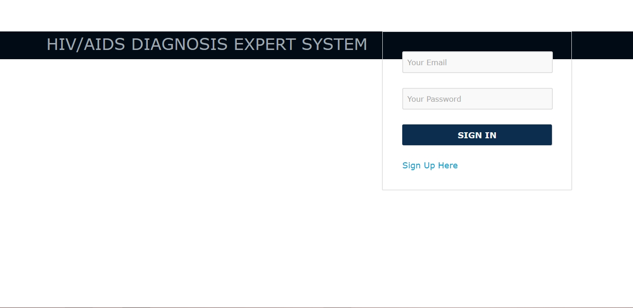

Registration page
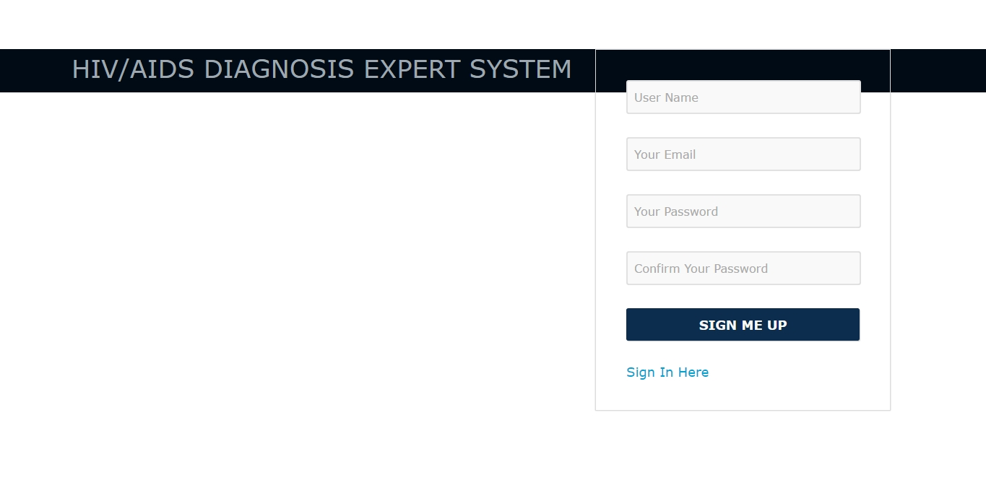
Welcome Page

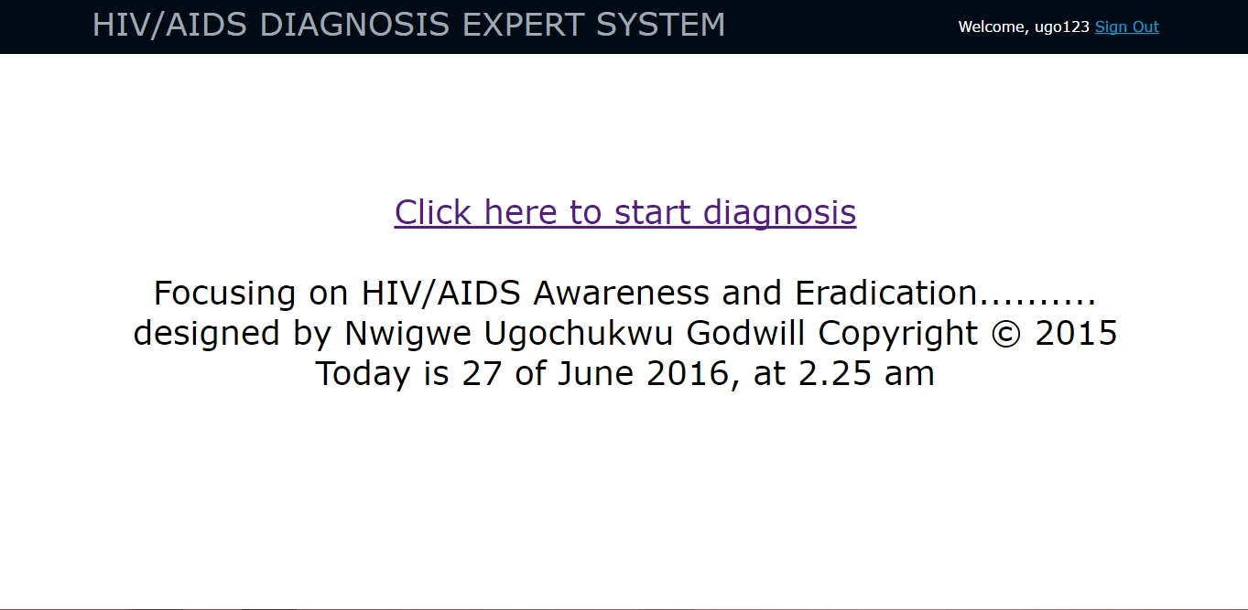

Analysis page
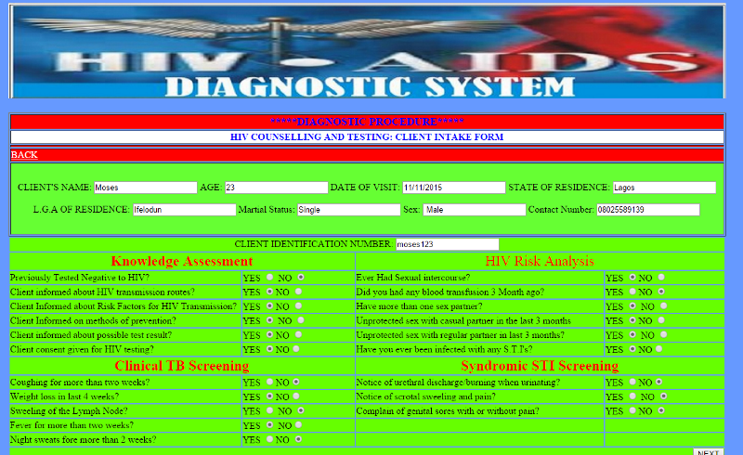

Suspected Positive test result page
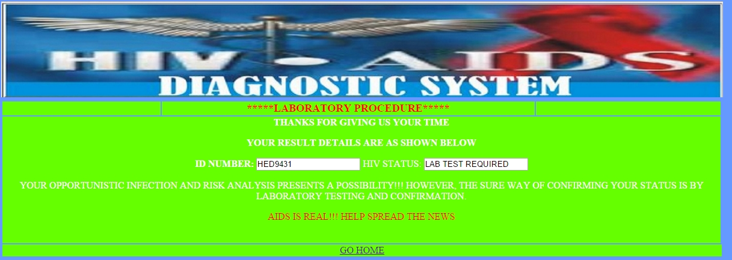

Determine test
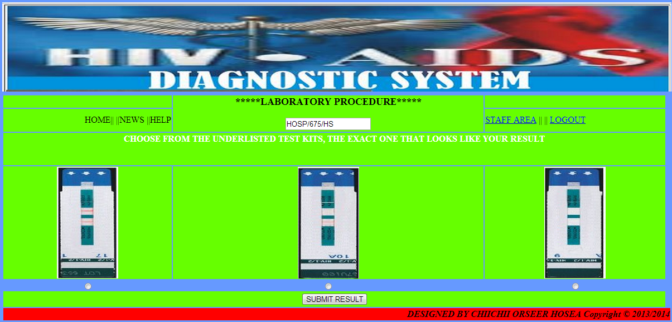

Uni-gold test
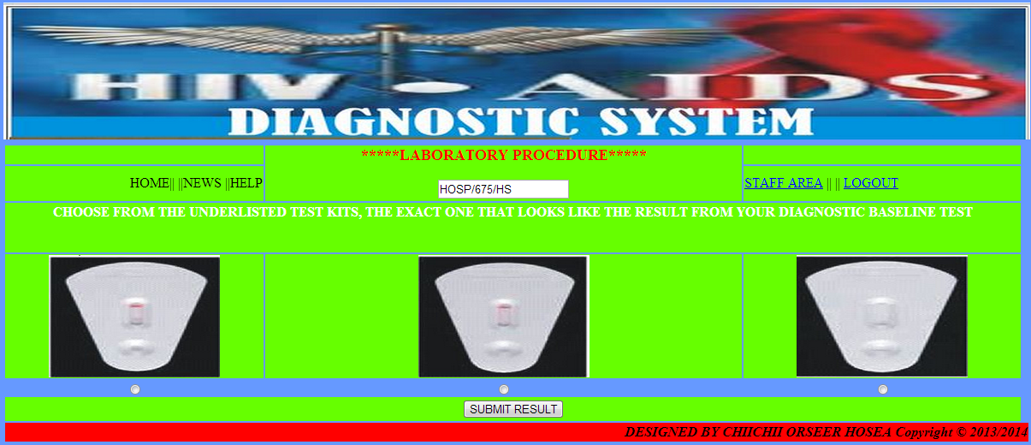

Stat-pak test
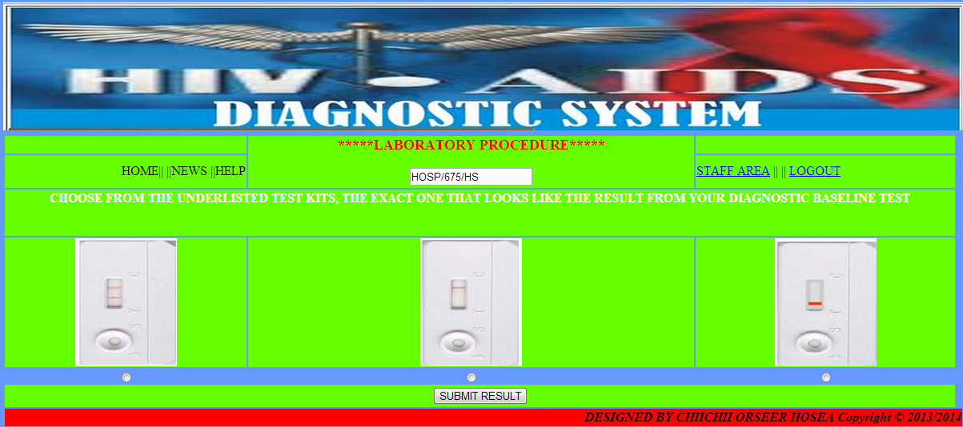

Positive test result page
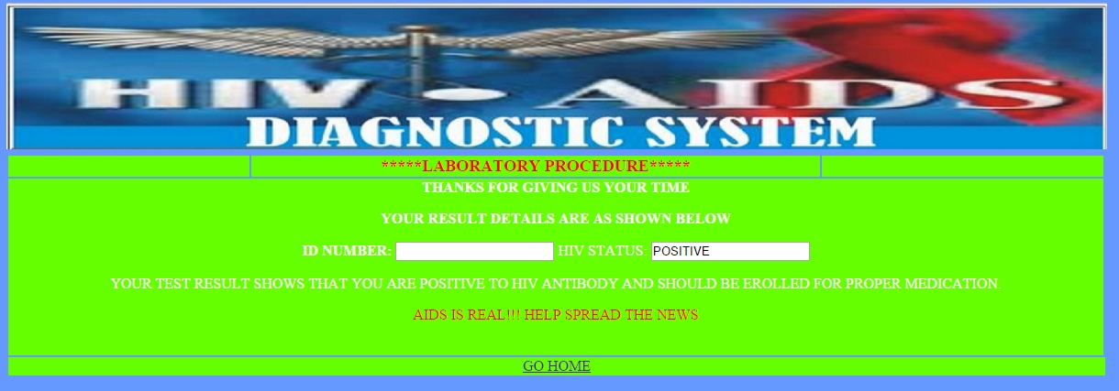

Negative test result page
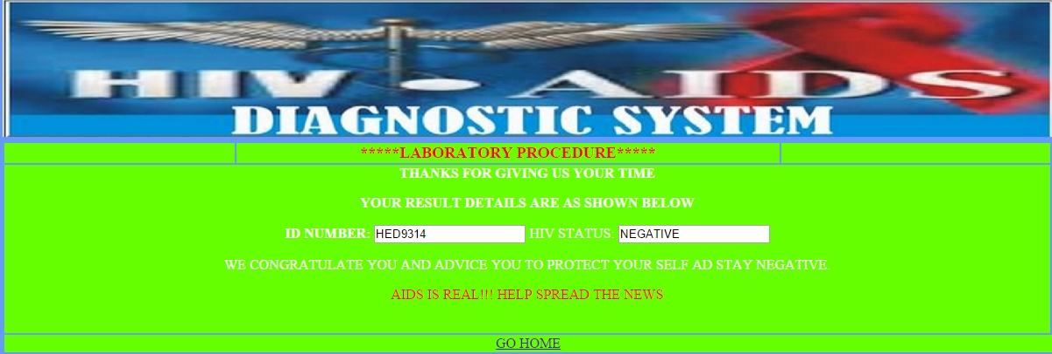
APPENDIX B
SOURCE CODES
INDEX PAGE (CLIENT LOGIN)
<html>
<head>
<title>HIV/AIDS DIAGNOSTIC SYSTEM</title>
<link href="stylesheets/default.css" rel="stylesheet" media="all" type="text/css">
</head>
<body>
<body bgcolor="#6699FF">
<tablewidth="1300"border="0"align="center"><tr> <tdcolspan="7"><divalign="center"><imgsrc="file:///C:/Users/Technical%20Service/Desktop/HDS%20FILES/includes/images/header.JPG.JPG" width="1200" height="160" /></div></td> </tr><tr bgcolor="#FFFFFF">
<?php require_once("includes/session.php");?> <?php require_once("includes/connection.php")?> <p> <?php include("includes/header.php") ?>
<?php if(isset($_POST['submit'])){ $userid=$_POST['userid']; $password=$_POST['password'];
$hash_password=sha1($password); $query="SELECT userid,password FROM staffs WHERE userid='{$userid}' AND password='{$hash_password}'"; $result=mysql_query($query,$connection); if(!$result){ die("Database Query Failed Due to: ".mysql_error());} if(mysql_num_rows($result)==1){ if($found_user=mysql_fetch_array($result)){$_SESSION['password']=$found_user['password']; $_SESSION['username']=$found_user['userid'];if($_SESSION['password']= $password) {header("Location:staffpage.php?userid={$_SESSION['username']}&&status={$field}");}
}else {header("Location:errorpage.php?userid={$_SESSION['username']}");} }else
{header("Location:errorpage.php");}} ?> <form name="form1" method="post" action="file:///C:/Users/Technical%20Service/Desktop/HDS%20FILES/basis/welcome%20page.html"> <table width="1200" border="0" align="center"> <tr> <td width="338"><font color="#CC0000"><em><strong>NEW CLIENT SHOULD <a href="file:///C:/Users/Technical%20Service/Desktop/HDS%20FILES/Start%20here.html">CLICK HERE</a></strong><a ="file:///C:/Users/Technical%20Service/Desktop/HDS%20FILES/hds.html"></a></em></font></td>
<td width="575" rowspan="3" background="includes/images/bgimage.jpg"><p align="center"><strong><font color="#000066">CLIENT LOGIN</font></strong></p> <p align="center"><font color="#000000">USERNAME</font><strong> <input name="userid" type="text" id="userid" size="25"> </strong></p> <div align="center"> <p> <input type="submit" name="submit" id="submit" value="ENTER"></p> <p>&nbsp;</p></div> </form> <p align="center">&nbsp; </p></td> <td width="338">&nbsp;</td> </tr> <tr> <td height="164" width="150"><p align="left"><a href="file:///C:/Users/Technical%20Service/Desktop/HDS%20FILES/Start%20here.html"></a><a href="file:///C:/Users/Technical%20Service/Desktop/HDS%20FILES/basis/Vision.html"></a><a href="file:///C:/Users/Technical%20Service/Desktop/HDS%20FILES/basis/Mission.html"></a><a href="file:///C:/Users/Technical%20Service/Desktop/HDS%20FILES/basis/Help.html"></a></p>
<p><img src="file:///C:/Users/Technical%20Service/Desktop/HDS%20FILES/includes/images/side.JPG.JPG" width="310" height="213" /></p></td>
<td><div align="justify"><font color="#000000">HIV/AIDS has been an epidemic not only in Nigeria but the world in general, many people have died due to this epidemic, the death rate is very high due to many reasons including lack of awareness, this system tend to provide this awareness to individuals and groups for proper handling of people living with the virus and also educates people on how to stay free from it.............</font></div></td>
</tr> <tr> <td height="143"><p><font color="#000000">The HIV/AIDS diagnostic system is a medical diagnostic system used in medical establishments trained by the system designers to cover HIV/AIDS related conditions, it helps in diagnosing clients, it is easy to use and reliable for medical establishments...</font></p></td>
<td><div align="right"><img src="file:///C:/Users/Technical%20Service/Desktop/HDS%20FILES/includes/images/index13.jpg.jpg" width="330" height="209" /></div></td> </tr> </body>
<script type="text/javascript">
var y=prompt("PLEASE ENTER YOUR NAME")
alert("WELCOME "+ y)
</script><script> alert (y +" HOW ARE YOU FEELING TODAY? PLEASE TYPE IN YOUR USERNAME IN ALPHANUMERIC ORDER, e.g ugo123,ada332 or Emeka222 AND CLICK ENTER LET'S GET STARTED");
document.getElementById("user id").style.left = "0px"; </script>
</html>
WELCOME PAGE
<html>
<head>
<title>HIV/AIDS DIAGNOSTIC SYSTEM</title>
<link href="stylesheets/default.css" rel="stylesheet" media="all" type="text/css">
</head>
<body bgcolor="#6699FF">
<table width="1300" border="0" align="center"> <tr>
</div></td></tr> <table width="1200"border="1" align="center"> <tr bgcolor="#FF0000"> <td bgcolor="#66FF00"><div align="right" <?php //Date echo "Today is ".date("l F d, Y");?> </div> <div align="right"></div></td> </tr> <tr bgcolor="#FF0000"> <td height="48"><p align="center"><strong><font color="#000000">WELCOME TO HIV/AIDS DIAGNOSTIC SYSTEM</font></strong></p></td> </tr> <tr> <td height="44" bgcolor="#66FF00"><div align="center" class="white"> <form id="form1" name="form1" method="post" action=""> </form> <strong> </div></td> </tr> <tr> <td bgcolor="#66FF00"><div align="center"><img src="file:///C:/Users/Technical%20Service/Desktop/HDS%20FILES/includes/images/header.JPG.JPG" width="1200" height="160" align="middle" /></div> <div align="center"></div></td> </tr> <tr> <td colspan="4" bgcolor="#FF0000"><div align="right" class="H"><em><strong> <div align="left"> <div align="right">DESIGNED BY NWIGWE UGOCHUKWU GODWILL Copyright &copy;2015 </tr></table><tr> <td width="338"><font color="#CC0000"><em><strong>NEW CLIENT SHOULD <a href="file:///C:/Users/Technical%20Service/Desktop/HDS%20FILES/Start%20here.html">CLICK HERE</a></strong><a ="file:///C:/Users/Technical%20Service/Desktop/HDS%20FILES/hds.html"></a></em></font></td><tr> <td height="164" width="150"><p align="left"><a href="file:///C:/Users/Technical%20Service/Desktop/HDS%20FILES/Start%20here.html">Home</a>|| ||<a href="file:///C:/Users/Technical%20Service/Desktop/HDS%20FILES/basis/Vision.html">Vision</a>|| ||<a href="file:///C:/Users/Technical%20Service/Desktop/HDS%20FILES/basis/Mission.html">Mission</a>|| ||<a href="file:///C:/Users/Technical%20Service/Desktop/HDS%20FILES/basis/Help.html">Help</a></p>
</body>
</html>
<td><divalign="right"><imgsrc="file:///C:/Users/Technical%20Service/Desktop/HDS%20FILES/includes/images/SNAG-15101823330500.png" width="330" height="155" /></div></td> </tr><div align="right"<tdbgcolor="#FF0000"><ahref="file:///C:/Users/Technical%20Service/Desktop/HDS%20FILES/basis/risk%20and%20opportunistic%20analysis%20page.html"><font color="#FF0000">NEXT</a> <tr> <td height="25" colspan="2"><divalign="center"><a href="file:///C:/Users/Technical%20Service/Desktop/HDS%20FILES/basis/Contact%20Me.html"> <fontcolor="#000000">ContactMe</a>||||<ahref="file:///C:/Users/Technical%20Service/Desktop/HDS%20FILES/basis/Help.html">Help</a>|| ||<a href="file:///C:/Users/Technical%20Service/Desktop/HDS%20FILES/basis/Terms%20and%20conditions.html">Terms&Conditions</a>||<a href="file:///C:/Users/Technical%20Service/Desktop/HDS%20FILES/basis/About.html">About</a>||<a href="file:///C:/Users/Technical%20Service/Desktop/HDS%20FILES/basis/FAQS.html">FAQS</a></div></td> </tr>

RISK AND OPPORTUNISTIC ANALYSIS PAGE
<html>
<head>
<title>HIV/AIDS DIAGNOSTIC SYSTEM</title>
<link href="stylesheets/default.css" rel="stylesheet" media="all" type="text/css">
</head>
<body bgcolor="#6699FF">
<table width="1300" border="0" align="center"> <tr>
<td colspan="7"><div align="center"><img src="file:///C:/Users/Technical%20Service/Desktop/HDS%20FILES/includes/images/header.JPG.JPG" width="1200" height="160" /></div></td> </tr><tr bgcolor="#FFFFFF">
<?php require_once("includes/session.php");?> <?php require_once("includes/connection.php")?> <p> <?php include("includes/header.php") ?>
</tr></table></body></html>
<?phprequire_once("../includes/session.php");?><?phprequire_once("../includes/connection.php")?><p><?php include("../includes/header.php") ?><?php //Date $date= date("l F d, Y");?> <?php $rand = rand(000,900);?><?php $rand = "HOSP"."/".$rand."/"."HS"?><?php $query4 = "SELECT * "; $query4 .= "FROM count "; $query4 .= "WHERE sno = '0' ";$result4 = mysql_query($query4, $connection); $found_count = mysql_fetch_array($result4); $mtotal = $found_count['mtotal']; $mtotal = $mtotal + 1; $query5 = "UPDATE count SET mtotal ='{$mtotal}' WHERE sno='0'"; $result5 = mysql_query($query5, $connection);?> <?php $query4 = "SELECT * "; $query4 .= "FROM count "; $query4 .= "WHERE sno = '0' "; $result4 = mysql_query($query4, $connection); $found_count = mysql_fetch_array($result4); $mtotal = $found_count['mtotal']; $ftotal = $found_count['ftotal']; $total = $found_count['total']; $total = $mtotal + $ftotal; $query6 = "UPDATE count SET total ='{$total}' WHERE sno='0'"; $result6 = mysql_query($query6, $connection); ?><?php if (isset($_GET['id'])) {$id = $_GET['id']; $id = @$_GET["id"]; $query1 = "SELECT * "; $query1 .= "FROM client "; $query1 .= "WHERE id = '{$id}' "; $result1 = mysql_query($query1, $connection); $found_client = mysql_fetch_array($result1); $_SESSION['id']=$found_client['id']; }?> <?php $yes_status = 'unchecked'; $no_status = 'unchecked'; $selected_radio = @$_POST['select']; if ($selected_radio==8) { $yes_status = 'checked'; }else if ($selected_radio == 0){$no_status = 'checked';}$selected_radio1 = @$_POST['select2']; if ($selected_radio1==8) {$yes_status = 'checked'; }else if ($selected_radio1 == 0) {$no_status = 'checked';} $selected_radio2 = @$_POST['select3'];if ($selected_radio2==8) {$yes_status = 'checked'; }else if ($selected_radio2 == 0){ $no_status = 'checked';} $selected_radio3 = @$_POST['select4'];if ($selected_radio3==8){$yes_status = 'checked';}else if ($selected_radio3 == 0){$no_status = 'checked';}$selected_radio4 = @$_POST['select5']; if ($selected_radio4==10){$yes_status = 'checked'; }else if ($selected_radio4 == 0){$no_status = 'checked';}$selected_radio5 = @$_POST['select6'];if ($selected_radio5==8){$yes_status = 'checked'; }else if ($selected_radio5 == 0){$no_status = 'checked';} $selected_radio6 = @$_POST['select7']; if ($selected_radio6==8){$yes_status = 'checked';}else if ($selected_radio6 == 0){$no_status = 'checked'; }$selected_radio7 = @$_POST['select8'];if ($selected_radio7==8){$yes_status = 'checked';}else if ($selected_radio7 == 0){$no_status = 'checked';} $selected_radio8 = @$_POST['select9']; if ($selected_radio8==8){$yes_status = 'checked'; }else if ($selected_radio8 == 0){ $no_status = 'checked';} $selected_radio9 = @$_POST['select10'];
if ($selected_radio9==8){$yes_status = 'checked'; }else if ($selected_radio9 == 0){ $no_status = 'checked';}$selected_radio10 = @$_POST['select11'];if ($selected_radio10==8){$yes_status = 'checked';}else if ($selected_radio10 == 0){$no_status = 'checked';} $selected_radio11 = @$_POST['select12']; if ($selected_radio11==10){$yes_status = 'checked';
}else if ($selected_radio11 == 0){$no_status = 'checked';} $selected_radio12 = @$_POST['select13']; if ($selected_radio12==10){$yes_status = 'checked';
}else if ($selected_radio12 == 0){$no_status = 'checked';}
$selected_radio13 = @$_POST['select14']; if ($selected_radio13==10){ $yes_status = 'checked'; }else if ($selected_radio13 == 0){ $no_status = 'checked';} $selected_radio14 = @$_POST['select15']; if ($selected_radio14==10){ $yes_status = 'checked'; }else if ($selected_radio14 == 0){ $no_status = 'checked';} $selected_radio15 = @$_POST['select16'];
if ($selected_radio15==10){ $yes_status = 'checked'; }else if ($selected_radio15 == 0){ $no_status = 'checked';} $selected_radio16 = @$_POST['select17']; if ($selected_radio16==10){ $yes_status = 'checked'; }else if ($selected_radio16 == 0){ $no_status = 'checked';} $selected_radio17 = @$_POST['select18']; if ($selected_radio17==0){
$yes_status = 'checked'; }else if ($selected_radio17 == 10){ $no_status = 'checked';} $selected_radio18 = @$_POST['select19']; if ($selected_radio18==10){ $yes_status = 'checked';}else if ($selected_radio18 == 0){ $no_status = 'checked';} $selected_radio19 = @$_POST['select20']; if ($selected_radio19==10){ $yes_status = 'checked'; }else if ($selected_radio19 == 0){ $no_status = 'checked';} $selected_radio20 = @$_POST['select21']; if ($selected_radio20==10){ $yes_status = 'checked'; }else if ($selected_radio20 == 0){ $no_status = 'checked';} $selected_radio21 = @$_POST['select22']; if ($selected_radio21==10){ $yes_status = 'checked'; }else if ($selected_radio21 == 0){ $no_status = 'checked'; }
$opt_analysis = @$selected_radio7 + @$selected_radio8 + @$selected_radio9 +@$selected_radio10 + @$selected_radio11 + @$selected_radio19 + @$selected_radio20 + @$selected_radio21; $opt_analysis =$opt_analysis."%";
$risk_analysis = @$selected_radio + @$selected_radio1 + @$selected_radio2 + @$selected_radio3 + @$selected_radio12 + @$selected_radio13 + @$selected_radio14 + @$selected_radio15 + @$selected_radio16 + @$selected_radio17; $risk_analysis = $risk_analysis."%"; ?>
<?php
if ( isset($_POST['submit'])){ $query = "UPDATE client SET opt_analysis='{$opt_analysis}', risk_analysis ='{$risk_analysis}' WHERE id='{$_SESSION['id']}'"; $result=mysql_query($query,$connection); if ($result)
header("Location:labTest.php?id={$_SESSION['id']}&opt_analysis={$opt_analysis}&risk_analysis={$risk_analysis}");
if(!$result){ die("Database query failed as: ".mysql_error());}} ?> <form action="file:///C:/Users/Technical%20Service/Desktop/HDS%20FILES/basis/Suspected%20Positive%20test%20result%20page.html" method="post"> <table align="center"> <td width="361"><table width="1200" border="1" align="left"> <tr> <td colspan="3" bgcolor="#FF0000"><div align="center" class="RED"> <div align="center"><font color="#0000FF" size="+1"><strong>*****DIAGNOSTIC PROCEDURE*****</strong></font></div></div></td></tr><tr><tdcolspan="3"bgcolor="#FFFFFF"><div align="center"><font color="#0000FF"><strong>HIV COUNSELLING AND TESTING: CLIENT INTAKE FORM</strong></font></div></td></tr><tr><td colspan="3" bgcolor="#FF0000"><div align="right"> <?php
//Date
echo "Today is ".date("l F d, Y");?></div></td> </tr> <tr><td colspan="3" bgcolor="#FF0000"><a href="file:///C:/Users/Technical%20Service/Desktop/HDS%20FILES/basis/welcome%20page.html"><font color="#FFFFFF">BACK</a></td> </tr> <tr> <td height="120" colspan="3" bgcolor="#66FF33"><p align="center">CLIENT'S NAME: <input name="name" type="text" id="name" value=""name"]?> AGE: <input name="age" type="text" id="age" value=""age"]?> DATE OF VISIT: <input name="dov" type="text" id="dov" value=""dov"]?>
STATE OF RESIDENCE: <input name="state" type="text" id="state" value=""state"]?> </p> <p align="center">L.G.A OF RESIDENCE: <inputname="lga" type="text" id="lga" value="<?php echo $found_client["lga"]?> <input name="status" type="text" id="status" value=""status"]?> Martial Status: <input name="status" type="text" id="status" value=""status"]?> Sex: <input name="sex" type="text" id="sex" value=" "sex"]?> Contact Number: <input name="number" type="text" id="number" value=""number"]?> </p> </td> </table> <table width="1200" border="0">
<tr> <td colspan="4" bgcolor="#66FF00"><div align="center">CLIENT IDENTIFICATION NUMBER : <input type="text" name="id" id="id" value=""id"]?> </div></td> </tr> <tr> <td colspan="2" bgcolor="#66FF00"><div align="center"><strong><font color="#FF0000" size="+2">Knowledge Assessment</font></strong></div></td><td colspan="2" bgcolor="#66FF00"><div align="center"><font color="#FF0000" size="+2">HIV Risk Analysis</font></div></td> </tr>
<tr> <td width="375" bgcolor="#66FF00">Previously Tested Negative to HIV?</font></td>
<td width="186" bgcolor="#66FF00">YES <input type="radio" name="select" value="8" />
NO <input type="radio" name="select" value="0" /></td><td width="413" bgcolor="#66FF00">Ever Had Sexual intercourse?</font></td><td width="198" bgcolor="#66FF00">YES <input type="radio" name="select13" value="10" />NO <input type="radio" name="select13" value="0" /></td> </tr> <tr> <td bgcolor="#66FF00">Client informed about HIV transmission routes?</font></td> <td bgcolor="#66FF00">YES <input type="radio" name="select2" value="8" />NO <input type="radio" name="select2" id="radio4" value="0" /></td> <td bgcolor="#66FF00">Did you had any blood transfusion 3 Month ago?</font></td> <td bgcolor="#66FF00">YES <input type="radio" name="select14" value="10" />NO <input type="radio" name="select14" value="0" /></td> </tr> <tr> <td bgcolor="#66FF00">Client Informed about Risk Factors for HIV Transmission?</font></td> <td bgcolor="#66FF00">YES <input type="radio" name="select3" value="8" />NO <input type="radio" name="select3" id="radio" value="0" /></td> <td bgcolor="#66FF00">Have more than one sex partner?</font></td><td bgcolor="#66FF00">YES <input type="radio" name="select15" value="10" /> NO <input type="radio" name="select15" value="0" /></td> </tr> <tr> <td bgcolor="#66FF00">Client Informed on methods of prevention?</font></td> <td bgcolor="#66FF00">YES <input type="radio" name="select4" value="8" /> NO
<input type="radio" name="select4" value="0" /></td> <td bgcolor="#66FF00">Unprotected sex with casual partner in the last 3 months</font></td> <td bgcolor="#66FF00">YES <input type="radio" name="select16" value="10" />NO <input type="radio" name="select16" value="0" /></td> </tr> <tr> <td bgcolor="#66FF00">Client informed about possible test result?</font></td> <td bgcolor="#66FF00">YES <input type="radio" name="select5" value="10" />NO <input type="radio" name="select5" value="0" /></td> <td bgcolor="#66FF00">Unprotected sex with regular partner in last 3 months?</td> <td bgcolor="#66FF00">YES <input type="radio" name="select17" value="0" /> NO <input type="radio" name="select17" value="10" /></td> </tr> <tr> <td bgcolor="#66FF00">Client consent given for HIV testing?</font></td> <td bgcolor="#66FF00">YES <input type="radio" name="select6" value="8" />NO<input type="radio" name="select6" value="0" /></td> <td bgcolor="#66FF00">Have you ever been infected with any S.T.I's?</font></td> <td bgcolor="#66FF00">YES <input type="radio" name="select18" value="10" />NO<input type="radio" name="select18" value="0" /></td> </tr> <tr> <td colspan="2"bgcolor="#66FF00"><divalign="center"><strong><fontcolor="#FF0000" size="+2">ClinicalTBScreening</font></strong></div></td><tdcolspan="2" bgcolor="#66FF00"><div align="center"><strong><fontcolor="#FF0000"size="+2">SyndromicSTIScreening</font></strong></div></td> </tr> <tr> <td bgcolor="#66FF00">Coughing for more than two weeks?</font></td> <td bgcolor="#66FF00">YES <input type="radio" name="select8" value="8" />NO<input type="radio" name="select8" value="0" /></td> <td bgcolor="#66FF00">Notice of urethral discharge/burning when urinating?</font></td> <td bgcolor="#66FF00">YES <input type="radio" name="select20" value="10" />NO<input type="radio" name="select20" value="0" /></td> </tr> <tr> <td bgcolor="#66FF00">Weight loss in last 4 weeks?</font></td> <td bgcolor="#66FF00">YES <input type="radio" name="select9" value="8" />NO<input type="radio" name="select9" value="0" /></td> <td bgcolor="#66FF00">Notice of scrotal sweeling and pain?</font></td> <td bgcolor="#66FF00">YES <input type="radio" name="select21" value="10" /> NO <input type="radio" name="select21" value="0" /></td> </tr> <tr> <td bgcolor="#66FF00">Constant headache for more than 2 weeks?</font></td> <td bgcolor="#66FF00">YES <input type="radio" name="select10" value="8" /> NO <input type="radio" name="select10" value="0" /></td> <td bgcolor="#66FF00">Complain of genital sores with or without pain?</font></td> <td bgcolor="#66FF00">YES <input type="radio" name="select22" value="10" />NO <input type="radio" name="select22" value="0" /></td> </tr> <tr> <td bgcolor="#66FF00">Fever for more than two weeks?</font></td> <td bgcolor="#66FF00">YES <input type="radio" name="select11" value="8" />
NO<input type="radio" name="select11" value="0" /></td> <td bgcolor="#66FF00">&nbsp;</td> <td bgcolor="#66FF00">&nbsp;</td> </tr> <tr> <td bgcolor="#66FF00">Night sweats for more than 2 weeks?</font></td> <td bgcolor="#66FF00">YES <input type="radio" name="select12" value="10" />NO <input type="radio" name="select12" value="0" /></td> <td bgcolor="#66FF00">&nbsp;</td> <td bgcolor="#66FF00">&nbsp;</td> </tr> <tr> <td colspan="4" bgcolor="#66FF00"><div align="right"> <input name="submit" type="submit" id="submit" value="NEXT" /> </div></td> </tr> </table> <p> <td colspan="3" bgcolor="#FF0000"><a href="file:///C:/Users/Technical%20Service/Desktop/HDS%20FILES/basis/Negative%20test%20result%20page.html"><font color="#FFFFFF">CLICK HERE IF YOU ONLY SELECTED "YES" IN KNOWLEDEGE ASSESSMENT </a></td> </p>
<p align="center">
<?php if(!empty($message)){echo "<font color=\"#330033\" </font>
</p> <?php include("../includes/footer.php") ?>
<script> alert ("WELCOME TO THE RISK AND OPPORTUNISTIC ANALYSIS PAGE, PLEASE CAREFULLY FILL IN THE FORM, ANSWER THE QUESTIONNAIRE WITH UTMOST HONESTY AND PRINT THIS PAGE. BE REST ASSURED THAT YOUR PRIVACY IS INTACT. GOOD LUCK");
document.getElementById("user id").style.left = "0px"; </script>
<script type="text/javascript">
var x=Math.floor((Math.random() *10000) +1);
alert("NOTE : YOUR IDENTIFICATION NUMBER IS HED" +x)
</script>
SUSPECTED POSITIVE TEST RESULT PAGE
<html>
<head>
<title>HIV/AIDS DIAGNOSTIC SYSTEM</title>
<link href="stylesheets/default.css" rel="stylesheet" media="all" type="text/css">
</head>
<body bgcolor="#6699FF">
<table width="1300" border="0" align="center"> <tr>
<tdcolspan="7"><divalign="center"><imgsrc="file:///C:/Users/Technical%20Service/Desktop/HDS%20FILES/includes/images/header.JPG.JPG" width="1200" height="160" /></div></td> </tr><tr bgcolor="#FFFFFF">
<?php require_once("includes/session.php");?> <?php require_once("includes/connection.php")?><?php include("includes/header.php") ?><?php
$id = @$_GET["id"]; $query1 = "SELECT * "; $query1 .= "FROM client "; $query1 .= "WHERE id = '{$id}' "; $result1 = mysql_query($query1, $connection); $found_client = mysql_fetch_array($result1);?><table width="1200" border="0" align="center"> <tr> <td width="262" bgcolor="#66FF00"><div align="right"></div></td> <td width="619" bgcolor="#66FF00"><div align="center"> <p><font color="#FF0000" size="+1"><strong><font color="#FF0000">*****LABORATORY PROCEDURE*****</strong></font> </p> </div></td> <td width="305" bgcolor="#66FF00">&nbsp;</td> </tr> <tr> <td height="34" colspan="3" bgcolor="#66FF00"><p align="center"><font color="#FFFFFF"><strong>THANKS FOR GIVING US YOUR TIME</strong></font> <p align="center"> <strong><font color="#FFFFFF">YOUR RESULT DETAILS ARE AS SHOWN BELOW</font></strong> <p align="center"><strong><font color="#FFFFFF">IDNUMBER:<inputname="id"type="text"id="id"value=""> </font></strong><font color="#FFFFFF"> HIV STATUS: </font> <input name="lab_test" type="text" id="lab_test" value="LAB TEST REQUIRED"readonly=""> <p align="center"> <font color="#FFFFFF"> YOUR OPPORTUNISTIC INFECTION AND RISK ANALYSIS PRESENTS A POSSIBILITY!!! HOWEVER, THE SURE WAY OF CONFIRMING YOUR STATUS IS BY LABORATORY TESTING AND CONFIRMATION.</font> <p align="center"><font color="#FF0000">AIDS IS REAL!!! HELP SPREAD THE NEWS </font> <div align="center"> <p><br/> </p> </div> </tr> <tr> <td colspan="4" bgcolor="#66FF00"><div align="center"><a href="file:///C:/Users/Technical%20Service/Desktop/HDS%20FILES/Start%20here.html">GO HOME</a></div> </form> </tr>
<?php include("includes/footer.php") ?

LAB TEST
<html>
<head>
<title>HIV/AIDS DIAGNOSTIC SYSTEM</title>
<link href="stylesheets/default.css" rel="stylesheet" media="all" type="text/css">
</head>
<body bgcolor="#6699FF">
<table width="1300" border="0" align="center"> <tr>
<tdcolspan="7"><divalign="center"><imgsrc="file:///C:/Users/Technical%20Service/Desktop/HDS%20FILES/includes/images/header.JPG.JPG" width="1200" height="160" /></div></td> </tr><tr bgcolor="#FFFFFF">
<?php require_once("includes/session.php");?> <?php require_once("includes/connection.php")?> <p> <tr> <td bgcolor="#66FF33"><div align="center">
<?php require_once("includes/session.php");?>
<?php require_once("includes/connection.php")?><?php include("includes/header.php") ?>
<?php $positive_status = 'unchecked'; $negative_status = 'unchecked'; $invalid_status = 'unchecked'; $selected_radio=""; $status ="";

if (isset($_POST['submit'])){$selected_radio = $_POST['selection']; if ($selected_radio=='positive'){ $positive_status = 'checked'; }else if ($selected_radio == 'negative'){ $negative_status = 'checked'; }else if ($selected_radio == 'invalid'){ $invalid_status = 'checked';} $lab_test = $selected_radio; $id = $_SESSION['id'];
$query = "UPDATE client SET lab_test ='{$lab_test}' WHERE id='{$_SESSION['id']}'"; $result=mysql_query($query,$connection); if($result){ if($positive_status == 'checked')
{header("Location:uni.php?id={$_SESSION['id']}");} else if($negative_status == 'checked')
{header("Location:finishn.php?id={$_SESSION['id']}");}
else if($invalid_status == 'checked') {header("Location:det1.php?id={$id}");} } else {$message="The result could not be recorded".mysql_error()."<br/> <form name="form1" method="post" action="det.php"> <table width="1200" border="0" align="center"> <tr> <td width="250" bgcolor="#66FF00">&nbsp;</td> <td width="462" rowspan="2" bgcolor="#66FF00"><div align="center"> <p><font color="#FF0000" size="+1"><strong>*****LABORATORY PROCEDURE DETERMINE TEST KIT*****</strong></font></p> <p>
<input type="text" name="id" id="id" value= " " align="middle" </p> </div></td> <td width="268" bgcolor="#66FF00">&nbsp;</td> </tr> </div></td> <td bgcolor="#66FF00"><a href="file:///C:/Users/Technical%20Service/Desktop/HDS%20FILES/Start%20here.html">CLIENT AREA</a> </td> </tr> <tr> <td height="34" colspan="3" bgcolor="#66FF00"><p align="center"> <p align="center"><font color="#FFFFFF"><strong>CHOOSE FROM THE UNDERLISTED TEST KITS, THE EXACT ONE THAT LOOKS LIKE THE RESULT FROM YOUR DIAGNOSTIC AND CLICK BELOW. FROM LEFT TO RIGHT IS A,B,C.</strong></font></p> <div align="center"> <p><br/> </p> </div> </tr> <tr> <td bgcolor="#66FF00"><div align="center"><img src="file:///C:/Users/Technical%20Service/Desktop/HDS%20FILES/includes/images/determine%20p.JPG.JPG" width="110" height="200"></div> <td bgcolor="#66FF00"><div align="center"><img src="file:///C:/Users/Technical%20Service/Desktop/HDS%20FILES/includes/images/determine%20n.JPG.JPG" width="110" height="200"></div> <td bgcolor="#66FF00"><div align="center"><img src="file:///C:/Users/Technical%20Service/Desktop/HDS%20FILES/includes/images/determine%20i.JPG.JPG" width="110" height="200"></div> <tr> <td> <div align="center"> <input type="radio" name="selection" value="positive"> </div> <td> <div align="center"> <input type="radio" name="selection" value="negative"> </div> <td> <div align="center"> <input type="radio"name="selection"value="invalid"></div></tr><li><td colspan="3" bgcolor="#FF0000"><a href="file:///C:/Users/Technical%20Service/Desktop/HDS%20FILES/HDS%20Official%20use%20only%20(LAB%20TEST)/basic/Positive%20test%20result%20page.html"><font color="#FFFFFF">A </li> <licolspan="3"bgcolor="#FF0000"><a href="file:///C:/Users/Technical%20Service/Desktop/HDS%20FILES/HDS%20Official%20use%20only%20(LAB%20TEST)/basic/Negative%20test%20result%20page.html"><font color="#FFFFFF">B </li><licolspan="3"bgcolor="#FF0000"><ahref="file:///C:/Users/Technical%20Service/Desktop/HDS%20FILES/HDS%20Official%20use%20only%20(LAB%20TEST)/basic/Invalid%20test%20result%20page.html"><font color="#FFFFFF">C </li></a></td> </div> </form> <td width="2"></td> </tr>
<?php include("includes/footer.php")
<?php require_once("includes/session.php"); ?><?php require_once("includes/connection.php")?><?php include("includes/header.php") ?> <?php
$positive_status = 'unchecked'; $negative_status = 'unchecked'; $invalid_status = 'unchecked';
$selected_radio=""; $status =""; if (isset($_POST['submit'])){ $selected_radio = $_POST['selection']; if ($selected_radio=='positive'){$positive_status = 'checked';
}else if ($selected_radio == 'negative'){ $negative_status = 'checked'; }else if ($selected_radio == 'invalid'){ $invalid_status = 'checked';}$lab_test = $selected_radio; $id = $_SESSION['id']; $query = "UPDATE client SET lab_test ='{$lab_test}' WHERE id='{$_SESSION['id']}'"; $result=mysql_query($query,$connection); if($result){ if($positive_status == 'checked')
{header("Location:finishp.php?id={$_SESSION['id']}");} else if($negative_status == 'checked')
{header("Location:stat.php?id={$_SESSION['id']}");} else if($invalid_status == 'checked'){ header("Location:uni1.php?id={$_SESSION['id']}");}} } ?>
<form name="form1" method="post" action="uni.php"> <table width="1200" border="0" align="center"> <tr> <td width="250" bgcolor="#66FF00">&nbsp;</td> <td width="462" rowspan="2" bgcolor="#66FF00"><div align="center"> <p><font color="#FF0000" size="+1"><strong>*****LABORATORY PROCEDURE UNI-GOLD TEST*****</strong></font></p> <p> <input type="text" name="id" id="id" value=" " align="middle" </p> </div></td> <td width="268" bgcolor="#66FF00">&nbsp;</td> </tr> <td bgcolor="#66FF00"><a href="file:///C:/Users/Technical%20Service/Desktop/HDS%20FILES/Start%20here.html">CLIENT AREA</a> </td> </tr> <tr> <td height="34" colspan="3" bgcolor="#66FF00"><p align="center"> <p align="center"><font color="#FFFFFF"><strong>CHOOSE FROM THE UNDERLISTED TEST KITS, THE EXACT ONE THAT LOOKS LIKE THE RESULT FROM YOUR DIAGNOSTIC AND CLICK BELOW. FROM LEFT TO RIGHT IS A,B,C. </strong></font> <strong><font color="#FFFFFF">BASELINE TEST </font></strong></p> <div align="center"> <p><br/> </p> </div></tr> <tr> <td bgcolor="#66FF00"><div align="center"><img src="file:///C:/Users/Technical%20Service/Desktop/HDS%20FILES/includes/images/uni%20P.JPG.JPG" width="200" height="143"></div> <td bgcolor="#66FF00"><div align="center"><img src="file:///C:/Users/Technical%20Service/Desktop/HDS%20FILES/includes/images/uni%20N.JPG.JPG" width="200" height="143"></div> <td bgcolor="#66FF00"><div align="center"><img src="file:///C:/Users/Technical%20Service/Desktop/HDS%20FILES/includes/images/uni%20I.JPG.JPG" width="200" height="143"></div> <tr> <td> <div align="center"> <input type="radio" name="selection" value="positive"> </div> <td> <div align="center"> <input type="radio" name="selection" value="negative" </div> <td> <div align="center"> <input type="radio" name="selection" value="invalid" </div> </tr> <li> <td colspan="3" bgcolor="#FF0000"><a href="file:///C:/Users/Technical%20Service/Desktop/HDS%20FILES/HDS%20Official%20use%20only%20(LAB%20TEST)/basic/Positive%20test%20result%20page.html"><font color="#FFFFFF">A </li> <licolspan="3"bgcolor="#FF0000"><a href="file:///C:/Users/Technical%20Service/Desktop/HDS%20FILES/HDS%20Official%20use%20only%20(LAB%20TEST)/basic/Negative%20test%20result%20page.html"><font color="#FFFFFF">B </li><licolspan="3"bgcolor="#FF0000"><a href="file:///C:/Users/Technical%20Service/Desktop/HDS%20FILES/HDS%20Official%20use%20only%20(LAB%20TEST)/basic/Invalid%20test%20result%20page.html"><font color="#FFFFFF">C </li></a> </div> </form> <td width="2"></td> </tr> <?php include("includes/footer.php") ?>
<?php require_once("includes/session.php");?>
<?php require_once("includes/connection.php")?> <?php include("includes/header.php") ?>
<?php $positive_status = 'unchecked'; $negative_status = 'unchecked'; $invalid_status = 'unchecked'; $selected_radio=""; $status =""; if (isset($_POST['submit'])){ $selected_radio = $_POST['selection']; if ($selected_radio=='positive'){ $positive_status = 'checked';
}else if ($selected_radio == 'negative'){ $negative_status = 'checked'; }else if ($selected_radio == 'invalid'){ $invalid_status = 'checked';} $lab_test = $selected_radio; $id = $_SESSION['id'];
$query = "UPDATE client SET lab_test ='{$lab_test}' WHERE id='{$_SESSION['id']}'"; $result=mysql_query($query,$connection); if($result){ if($positive_status == 'checked')
{header("Location:finishp.php?id={$_SESSION['id']}"); } else if($negative_status == 'checked') {header("Location:finishn.php?id={$_SESSION['id']}");} else if($invalid_status == 'checked') {header("Location:stat1.php?id={$_SESSION['id']}"); }}}
?> <form name="form1" method="post" action="stat.php"><tr> </div> </form> <td width="2"></td> </tr> <table width="1200" border="0" align="center"> <tr> <td width="250" bgcolor="#66FF00">&nbsp;</td> <td width="462" rowspan="2" bgcolor="#66FF00"><div align="center"> <p><font color="#FF0000" size="+1"><strong>*****LABORATORY PROCEDURE STAT-PACK TEST*****</strong></font></p> <p> <input type="text" name="id" id="id" value=" " align="middle" </p> </div></td> <td width="268" bgcolor="#66FF00">&nbsp;</td> </tr> </div></td><td bgcolor="#66FF00"><a href="file:///C:/Users/Technical%20Service/Desktop/HDS%20FILES/Start%20here.html">CLIENT AREA</a> </td> </tr> <tr> <td height="34" colspan="3" bgcolor="#66FF00"><p align="center"> <p align="center"><font color="#FFFFFF"><strong>CHOOSE FROM THE UNDERLISTED TEST KITS, THE EXACT ONE THAT LOOKS LIKE THE RESULT FROM YOUR DIAGNOSTIC AND CLICK BELOW. FROM LEFT TO RIGHT IS A,B,C. </strong></font> <strong><font color="#FFFFFF">BASELINE TEST </font></strong></p> <div align="center"> <p><br/> </p> </div> </tr> <tr> <td bgcolor="#66FF00"><div align="center"><img src="file:///C:/Users/Technical%20Service/Desktop/HDS%20FILES/includes/images/stat%20P.JPG.JPG" width="127" height="160"></div> <td bgcolor="#66FF00"><div align="center"><img src="file:///C:/Users/Technical%20Service/Desktop/HDS%20FILES/includes/images/stat%20N.JPG.JPG" width="127" height="160"></div> <td bgcolor="#66FF00"><div align="center"><img src="file:///C:/Users/Technical%20Service/Desktop/HDS%20FILES/includes/images/stat%20I.JPG.JPG" width="127" height="160"></div> <tr> <td> <div align="center"> <input type="radio" name="selection" value="positive"> </div> <td> <div align="center"> <input type="radio" name="selection" value="negative"> </div> <td> <div align="center"> <input type="radio" name="selection" value="invalid"> </div> </tr> <li> <td colspan="3" bgcolor="#FF0000"><a href="file:///C:/Users/Technical%20Service/Desktop/HDS%20FILES/HDS%20Official%20use%20only%20(LAB%20TEST)/basic/Positive%20test%20result%20page.html"><font color="#FFFFFF">A </li> <li colspan="3" bgcolor="#FF0000"><a href="file:///C:/Users/Technical%20Service/Desktop/HDS%20FILES/HDS%20Official%20use%20only%20(LAB%20TEST)/basic/Negative%20test%20result%20page.html"><font color="#FFFFFF">B </li> <li colspan="3" bgcolor="#FF0000"><a href="file:///C:/Users/Technical%20Service/Desktop/HDS%20FILES/HDS%20Official%20use%20only%20(LAB%20TEST)/basic/Invalid%20test%20result%20page.html"><font color="#FFFFFF">C </li></a> </div> </form> <td width="2"></td> </tr>

NEGATIVE RESULT
<!--savedfrom url=(0141)file:///C:/Users/Technical%20Service/Desktop/HDS%20FILES/HDS%20Official%20use%20only%20(LAB%20TEST)/basic/Invalid%20test%20result%20page.html -->
<html><head><meta http-equiv="Content-Type" content="text/html; charset=windows-1252">
<title>HIV/AIDS DIAGNOSTIC SYSTEM</title>
<link href="file:///C:/Users/Technical%20Service/Desktop/HDS%20FILES/HDS%20Official%20use%20only%20(LAB%20TEST)/basic/stylesheets/default.css" rel="stylesheet" media="all" type="text/css">
</head>
<body bgcolor="#6699FF">
<table width="1300" border="0" align="center"> <tbody><tr>
<td colspan="7"><div align="center"><img src="./Negative test result page_files/header.JPG.JPG" width="1200" height="160"></div></td> </tr><tr bgcolor="#FFFFFF">
<!--?php require_once("includes/session.php");?--> <!--?php require_once("includes/connection.php")?--><!--?php include("includes/header.php") ?--><!--?php
$id = @$_GET["id"]; $query1 = "SELECT * "; $query1 .= "FROM client "; $query1 .= "WHERE id = '{$id}' "; $result1 = mysql_query($query1, $connection); $found_client = mysql_fetch_array($result1);?--></tr></tbody></table><table width="1200" border="0" align="center"> <tbody><tr> <td width="262" bgcolor="#66FF00"><div align="right"></div></td> <td width="619" bgcolor="#66FF00"><div align="center"> <p><font color="#FF0000" size="+1"><strong><font color="#FF0000">*****LABORATORY PROCEDURE*****</font></strong> </font></p><font color="#FF0000" size="+1"> </font></div></td> <td width="305" bgcolor="#66FF00">&nbsp;</td> </tr> <tr> <td height="34" colspan="3" bgcolor="#66FF00"><p align="center"><font color="#FFFFFF"><strong>THANKS FOR GIVING US YOUR TIME</strong></font> </p><p align="center"> <strong><font color="#FFFFFF">YOUR RESULT DETAILS ARE AS SHOWN BELOW</font></strong> </p><p align="center"><strong><font color="#FFFFFF">ID NUMBER: <input name="id" type="text" id="id" value=""> </font></strong><font color="#FFFFFF"> HIV STATUS: </font> <input name="lab_test" type="text" id="lab_test" value="NEGATIVE" readonly=""> </p><p align="center"> <font color="#FFFFFF">WE CONGRATULATE YOU AND ADVICE YOU TO PROTECT YOUR SELF AD STAY NEGATIVE.</font> </p><p align="center"><font color="#FF0000">AIDS IS REAL!!! HELP SPREAD THE NEWS </font> </p><div align="center"> <p><br> </p> </div> </td></tr> <tr> <td colspan="4" bgcolor="#66FF00"><div align="center"><a href="file:///C:/Users/Technical%20Service/Desktop/HDS%20FILES/HDS%20Official%20use%20only%20(LAB%20TEST)/basic/lab%20test%20page.html">GO HOME</a></div> </td></tr>
<!--?php include("includes/footer.php") ?

--></tbody></table></body></html>

POSITIVE RESULT
<html>
<head>
<title>HIV/AIDS DIAGNOSTIC SYSTEM</title>
<link href="stylesheets/default.css" rel="stylesheet" media="all" type="text/css">
</head>
<body bgcolor="#6699FF">
<table width="1300" border="0" align="center"> <tr>
<tdcolspan="7"><divalign="center"><imgsrc="file:///C:/Users/Technical%20Service/Desktop/HDS%20FILES/includes/images/header.JPG.JPG" width="1200" height="160" /></div></td> </tr><tr bgcolor="#FFFFFF">
<?php require_once("includes/session.php");?> <?php require_once("includes/connection.php")?><?php include("includes/header.php") ?><?php
$id = @$_GET["id"]; $query1 = "SELECT * "; $query1 .= "FROM client "; $query1 .= "WHERE id = '{$id}' "; $result1 = mysql_query($query1, $connection); $found_client = mysql_fetch_array($result1);?><table width="1200" border="0" align="center"> <tr> <td width="262" bgcolor="#66FF00"><div align="right"></div></td> <td width="619" bgcolor="#66FF00"><div align="center"> <p><font color="#FF0000" size="+1"><strong><font color="#FF0000">*****LABORATORY PROCEDURE*****</strong></font> </p> </div></td> <td width="305" bgcolor="#66FF00">&nbsp;</td> </tr> <tr> <td height="34" colspan="3" bgcolor="#66FF00"><p align="center"><font color="#FFFFFF"><strong>THANKS FOR GIVING US YOUR TIME</strong></font> <p align="center"> <strong><font color="#FFFFFF">YOUR RESULT DETAILS ARE AS SHOWN BELOW</font></strong> <p align="center"><strong><font color="#FFFFFF">ID NUMBER: <input name="id" type="text" id="id" value=""> </font></strong><font color="#FFFFFF"> HIV STATUS: </font> <input name="lab_test" type="text" id="lab_test" value="POSITIVE" readonly/> <p align="center"> <font color="#FFFFFF">YOUR TEST RESULT SHOWS THAT YOU ARE POSITIVE TO HIV ANTIBODY AND SHOULD BE EROLLED FOR PROPER MEDICATION.</font> <p align="center"><font color="#FF0000">AIDS IS REAL!!! HELP SPREAD THE NEWS </font> <div align="center"> <p><br/> </p> </div> </tr> <tr> <td colspan="4" bgcolor="#66FF00"><div>align="center"><a href="file:///C:/Users/Technical%20Service/Desktop/HDS%20FILES/HDS%20Official%20use%20only%20(LAB%20TEST)/basic/lab%20test%20page.html">GO HOME</a></div> </form> </tr>
<?php include("includes/footer.php") ?

INVALID RESULT
<html>
<head>
<title>HIV/AIDS DIAGNOSTIC SYSTEM</title>
<link href="stylesheets/default.css" rel="stylesheet" media="all" type="text/css">
</head>
<body bgcolor="#6699FF">
<table width="1300" border="0" align="center"> <tr>
<td colspan="7"><div align="center"><img src="file:///C:/Users/Technical%20Service/Desktop/HDS%20FILES/includes/images/header.JPG.JPG" width="1200" height="160" /></div></td> </tr><tr bgcolor="#FFFFFF">
<?php require_once("includes/session.php");?> <?php require_once("includes/connection.php")?><?php include("includes/header.php") ?><?php
$id = @$_GET["id"]; $query1 = "SELECT * "; $query1 .= "FROM client "; $query1 .= "WHERE id = '{$id}' "; $result1 = mysql_query($query1, $connection); $found_client = mysql_fetch_array($result1);?><table width="1200" border="0" align="center"> <tr> <td width="262" bgcolor="#66FF00"><div align="right"></div></td> <td width="619" bgcolor="#66FF00"><div align="center"> <p><font color="#FF0000" size="+1"><strong><font color="#FF0000">*****LABORATORY PROCEDURE*****</strong></font> </p> </div></td> <td width="305" bgcolor="#66FF00">&nbsp;</td> </tr> <tr> <td height="34" colspan="3" bgcolor="#66FF00"><p align="center"><font color="#FFFFFF"><strong>THANKS FOR GIVING US YOUR TIME</strong></font> <p align="center"> <strong><font color="#FFFFFF">YOUR RESULT DETAILS ARE AS SHOWN BELOW</font></strong> <p align="center"><strong><font color="#FFFFFF">ID NUMBER: <input name="id" type="text" id="id" value=""> </font></strong><font color="#FFFFFF"> HIV STATUS: </font> <input name="lab_test" type="text" id="lab_test" value="INVALID"readonly/> <p align="center"> <font color="#FFFFFF">YOUR TEST RESULT IS INVALID, PLEASE TRY AGAIN.</font> <p align="center"><font color="#FF0000">AIDS IS REAL!!! HELP SPREAD THE NEWS </font> <div align="center"> <p><br/> </p> </div> </tr> <tr> <td colspan="4" bgcolor="#66FF00"><div align="center"><a href="file:///C:/Users/Technical%20Service/Desktop/HDS%20FILES/HDS%20Official%20use%20only%20(LAB%20TEST)/basic/lab%20test%20page.html">GO HOME</a></div> </form> </tr>
<?php include("includes/footer.php")

